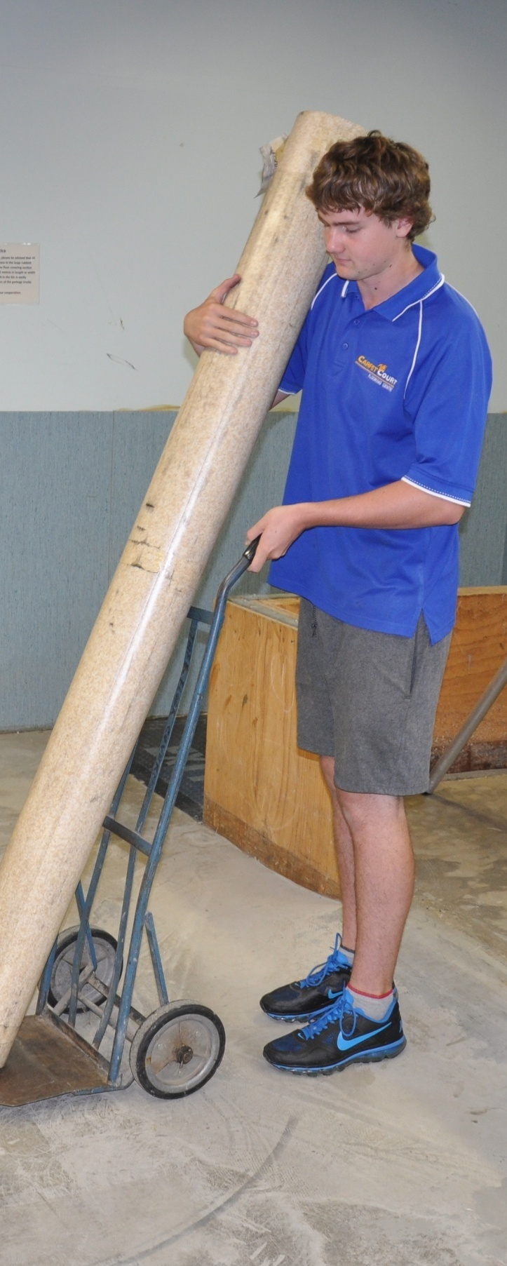
Supporting:
LMFFL2002A: Receive and prepare floor covering materials for installation
Preparing floor coverings
DRAFT VERSION
October 11
Name:
Workbook

Preparing floor coverings

Workbook
Containing learning activities and assignments for the unit of competency:
LMFFL2002A: Receive and prepare floor covering materials for installation

The assignment templates are also available in an electronic ‘Word’ version, downloadable from the Flooring technology website at:
www.flooringtech.com.au

Developed by Workspace Training for the 2012-2013
Workplace English Language and Literacy (WELL) Program
Flooring Technology resource development project
The resource is now managed by Manufacturing Skills Australia

ISBN: 978-1-925087-00-0
Funded under the Workplace English Language and Literacy Program by the Australian Government through the Department of Industry, Innovation, Climate Change, Science, Research and Tertiary Education
© Commonwealth of Australia 2013

CC BY-NC-SA

This work is copyright. Except where otherwise indicated, and save for the Commonwealth Coat of Arms, the Department has applied the Creative Commons Attribution-Noncommercial-Share Alike 3.0 Australia Licence to this work.
The Department of Industry, Innovation, Climate Change, Science, Research and Tertiary Education must be attributed as the author of the Department’s copyright material.
As far as practicable, material for which the copyright is owned by a third party has been clearly labelled. The Department has made all reasonable efforts to ensure that this material has been reproduced in the print-based resources and accompanying website with the full consent of the copyright owners.
Requests and enquiries concerning the Department’s copyright material should be addressed to:
The Legal Branch
Department of Industry, Innovation, Climate Change, Science, Research and Tertiary Education
GPO Box 9839 Canberra ACT 2601
Email: legalservices@innovation.gov.au
Questions about the design and content of the resource itself should be addressed to the project manager:
David McElvenny
Workspace Training
PO Box 1954 Strawberry Hills, NSW, 2012
Email: david@workspacetraining.com.au

Table of contents
Introduction 1
Part 1 Learning activities 3
Documentation 5
Materials and equipment 5
General health and safety 5
Looking after your body 6
On-site storage and handling 6
Conditioning 7
Part 2 Assignment 9
Assignment 11
Practical demonstrations 15

Introduction
Preparing floor coverings is a ‘learning unit’ from the Flooring Technology training resource. It supports the following competency from the Certificate III in Flooring Technology (LMF31208):
- LMFFL2002A: Receive and prepare floor covering materials for installation
To be assessed as competent, your assessor will use a range of methods to check your understanding of the concepts presented in the Learner guide for this unit and your practical ability to prepare, handle and store floor coverings.
These may include:
- written assignments
- practical demonstrations
- on-the-job discussions about how you go about particular activities
- learning activities undertaken while you’re progressing through the unit
- log book or work diary.

Literacy, numeracy and computer skills
Literacy is the ability to read and write. To complete this qualification, you will need sufficient literacy skills to produce a range of workplace documents. You will also need the skills to be able to read and understand documents such as order forms, installation instructions, project briefs and safe operating procedures.
Numeracy is the ability to work with numbers. Flooring installers need to do lots of measure-ups and calculations, so there will be many opportunities for you to learn and practice your numeracy skills.
When it comes to completing the written assignments for this qualification, a certain level of literacy ability is required to read the questions and write down your answers. There will also be times when you are asked to generate documents on a computer.
Obviously, it’s important that you clearly understand what the assignment is asking you to do, and that your submissions are a good reflection of what you really know. So if you’re having trouble reading the questions, writing down your answers, or using certain computer programs, make sure you speak to your trainer before you hand the assignment in.
There are various ways your trainer can help you. For example, they may be able to ask the assignment questions verbally and help you to write down your answers. They may also be able to show you sample answers to similar questions, which will let you look at the way they’re written and give you hints on how to write your own. You may also be allowed to do the assignment with the assistance of another person.

Applying for RPL
RPL stands for Recognition of Prior Learning. It is a form of assessment that acknowledges the skills and knowledge you have gained through:
- on-the-job experience
- formal training in other courses
- life experience, through your hobbies or other outside activities.
If you believe that you are already competent in some or all of the skills covered in this unit, ask your assessor about how to apply for RPL.

Using this workbook
All of the lessons in the Learner guide for this unit have learning activities at the end. Their purpose is to provide discussion points and questions to help reinforce your understanding of the concepts being presented.
There are also a range of assignments, which appear at the end of each section. These are designed to test your knowledge of the subject matter and ability to submit written responses in an acceptable format.
This workbook reproduces all of the learning activities and assignments in a format that lets you handwrite your answers to the questions.
Note that your trainer may ask you to produce a computer-generated document for all of the formal assignments, either printed out in hard copy or submitted electronically. To do this, go to the website version of the unit and look for the Assignment link in each section. This will allow you to type your answers into the ‘Word’ document and then either print it out or email it direct to your trainer as an attachment.
You may also be asked to share your learning activity answers electronically, especially if you are undertaking this unit by distance learning and are linked up with fellow students in other locations. This might be done through group emails or via a social networking site such as Facebook. In these cases, you should use the website resource rather than this workbook.

Part 1

Learning activities

Documentation
What sorts of documents do you take with you to the jobsite? Use the table below to name each document and list its purpose.
Document | Purpose

Materials and equipment
Name two tools that require replacement parts to be carried with them. Also name the parts that you need to keep on hand.
Tool | Replacement parts

General health and safety
Briefly describe what each of the following documents is designed for:
Document | Purpose
White Card
Safe Operating Procedure (SOP)
Safe Work Method Statement (SWMS)
Material Safety Data Sheet (MSDS)

Looking after your body
Give some examples of stretching exercises suitable for a floor layer who is about to unload and carry heavy rolls of flooring into an installation area. Describe the exercises and the benefit they would give you.
Description of exercise | Benefit

On-site storage and handling
Using the rule of thumb described in the Learner guide, calculate the length of a roll of flooring material. Show your workings in the space below. Then unroll the material and measure the actual length. Write this beside your estimated answer.

Conditioning
Go to the webpage below. Watch the Forbo Flooring clip and answer the following questions.
http://www.youtube.com/watch?v=o89QR8fYno4
- How long does Forbo recommend that the HVAC (heating, ventilation, air conditioning) system be left running – both before and after the floor covering is laid?
- In the sequence of trades undertaking work on the jobsite, where should floor laying be?

Part 2

Assignment

Assignment

Name |  | Date
Select two job sheets for separate installation projects. They should represent different types of floor covering material and different job types – such as one domestic and one commercial job.
For each project, answer the following questions.
Project 1
- Describe the installation project and state the type of floor covering used.
- What is the process for checking that the materials you are loading up in the warehouse are correct in terms of product type, quantity, etc? What would you do if any of the materials were incorrect, or if there was any damage that might cause problems on-site?
- What is the most efficient method for unloading the materials from your vehicle and taking them to the installation area? For example, will you need mechanical aids or an offsider?
- What sorts of damage do you need to protect the materials from on this type of jobsite? Name two possible types of damage and the methods you would use to ensure it doesn’t occur.
Type of damage | Solution
- What are the acclimatisation instructions for the floor covering? List the instructions specified by the manufacturer that are relevant to this jobsite
Project 2
- Describe the installation project and state the type of floor covering used.
- What is the process for checking that the materials you are loading up in the warehouse are correct in terms of product type, quantity, etc? What would you do if any of the materials were incorrect, or if there was any damage that might cause problems on-site?
- What is the most efficient method for unloading the materials from your vehicle and taking them to the installation area? For example, will you need mechanical aids or an offsider?
- What sorts of damage do you need to protect the materials from on this type of jobsite? Name two possible types of damage and the methods you would use to ensure it doesn’t occur.
Type of damage | Solution
- What are the acclimatisation instructions for the floor covering? List the instructions specified by the manufacturer that are relevant to this jobsite

Practical demonstrations
Your trainer may ask you to keep a log book or diary of the work you do on-the-job that relates to the practical components of this unit. This will help them to determine when you will have had sufficient hands-on practice in these tasks to undertake the assessment events.
It is likely that the practical components of this unit will be assessed while you are undertaking practical demonstration assessments for units of competency relating to laying floors. This will allow your assessor to carry out an integrated assessment of both units at the same time.
While you are demonstrating the hands-on aspects of these tasks, your assessor will be checking that you can:
- follow all work, health and safety requirements and environmental care procedures
- correctly interpret and complete company documents and work instructions
- prepare and package floor coverings correctly
- transport the floor coverings, unload them safety and store them in an appropriate area on-site
- acclimatise the floor coverings according to the manufacturer’s guidelines
- communicate and work effectively with other workers in the area
- prevent damage to goods, equipment and products
- work productively and in an efficient sequence with other trades
- modify activities and techniques used to suit different sites and working conditions.
Make sure you talk to your trainer or supervisor about any of the details you don’t understand, or aren’t ready to demonstrate, before the assessment events are organised. This will give you time to get the hang of the tasks you’ll need to perform, so that you’ll feel more confident when the time comes to be assessed.

