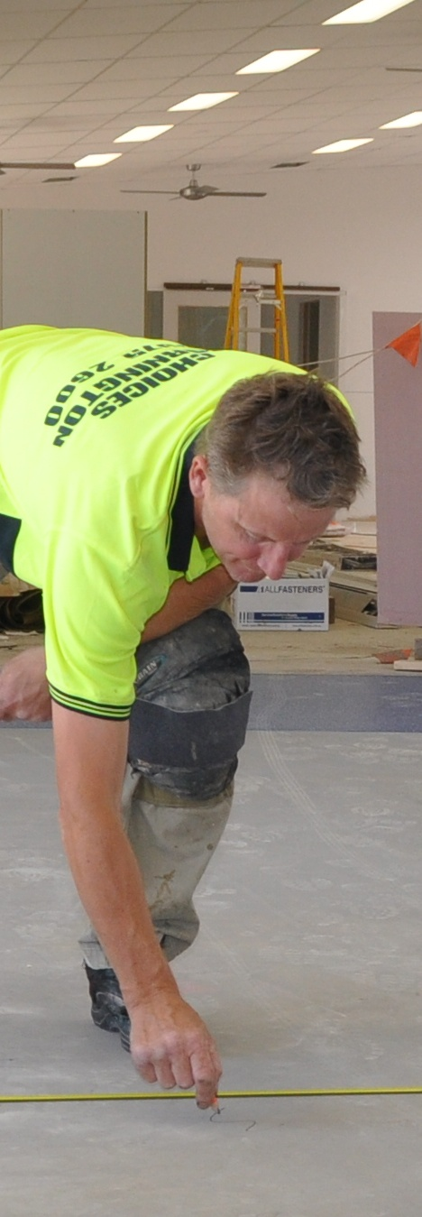
Making measurements
Supporting:

MSAPMOPS101A
Make measurements

DRAFT VERSION
October 11
Developed in 2012-2013 for the WELL Program
Learner guide and workbook

Making measurements

Learner guide
and Workbook

This unit is also available in an e-learning format, which contains additional photos, interactive exercises and a voice-over narration of the text. It can be viewed on CD-ROM, or live on the web at:
www.flooringtech.com.au

Developed by Workspace Training for the 2012-2013
Workplace English Language and Literacy (WELL) Program
Flooring Technology resource development project
The resource is now managed by Manufacturing Skills Australia

Copyright and disclaimer
ISBN: 978-0-9873327-4-5
Funded under the Workplace English Language and Literacy Program by the Australian Government through the Department of Industry, Innovation, Climate Change, Science, Research and Tertiary Education
© Commonwealth of Australia 2013
CC BY-NC-SA
This work is copyright. Except where otherwise indicated, and save for the Commonwealth Coat of Arms, the Department has applied the Creative Commons Attribution-Noncommercial-Share Alike 3.0 Australia Licence to this work.
The Department of Industry, Innovation, Climate Change, Science, Research and Tertiary Education must be attributed as the author of the Department’s copyright material.
As far as practicable, material for which the copyright is owned by a third party has been clearly labelled. The Department has made all reasonable efforts to ensure that this material has been reproduced in the print-based resources and accompanying website with the full consent of the copyright owners.
Requests and enquiries concerning the Department’s copyright material should be addressed to:
The Legal Branch
Department of Industry, Innovation, Climate Change, Science, Research and Tertiary Education
GPO Box 9839 Canberra ACT 2601
Email: legalservices@innovation.gov.au
Questions about the design and content of the resource itself should be addressed to the project manager:
David McElvenny
Workspace Training
PO Box 1954 Strawberry Hills, NSW, 2012
Email: david@workspacetraining.com.au

Disclaimer
The content of this learner guide is provided for educational purposes only. No claim is made as to the accuracy or authenticity of the content. The views expressed in this publication do not necessarily represent the view of the Minister for Tertiary Education, Skills, Science and Research or the Australian Government. The Australian Government does not give any warranty nor accept any liability in relation to the contents of this work.

About this resource
This Learner guide is part of a suite of resources developed for the Flooring Technology project, funded by the WELL Program. The resources support 19 competencies from the Certificate III in Flooring Technology (LMF31208). The project comprises a website and an accompanying set of Learner guides and work books.
The individual competencies are grouped into ‘Learning units’ as shown below. Each one is given a title describing the main theme of that set of integrated competencies.

Learning unit title Competencies covered
Safety at work MSAPMOHS200A: Work safely
LMFFL3002A: Establish and maintain a safe flooring technology work environment
Inspecting and testing subfloors LMFFL2004A: Moisture test timber and concrete floors
LMFFL3101A: Inspect sub-floors
Planning and costing LMFFL3001A: Plan and cost flooring technology work
Subfloor coatings and toppings LMFFL2102A: Prepare, select and apply smoothing and patching compounds
LMFFL2103A: Select and apply appropriate compounds and additives
LMFFL2105A: Select, prepare and apply moisture barriers and damp proof membranes to concrete sub-floors
Concrete grinding LMFFL2107A: Select, operate and maintain grinding equipment
Preparing floor coverings LMFFL2002A: Receive and prepare floor covering materials for installation
Lay flat vinyl LMFFL2301A: Install lay flat vinyl floor coverings
Resilient tiles LMFFL2302A: Install resilient tiles using standard installation practices
Commercial vinyl LMFFL3302A: Install commercial vinyl floor coverings
LMFFL3303A: Install resilient floor coverings using custom designs and decorative finishes
Linoleum LMFFL3301A: Install linoleum floor coverings
ESD floors LMFFL3308A: Install anti-static resilient floor coverings
LMFFL3309A: Install conductive resilient floor coverings
Making measurements MSAPMOPS101A: Make measurements
Working sustainably MSAENV272B: Participate in environmentally sustainable work practices
The purpose of these resources is to help trainee floor layers acquire the background knowledge needed to satisfy the theoretical components of the competencies covered in this project. However, the resources are not designed to replace the practical training necessary to develop the hands-on skills required. Learners will still need to receive extensive on-the-job training and supervision before they will be ready to be formally assessed in the relevant competencies.
E-learning version
All of the content material contained in this Learner guide is also available in an e-learning format, which has additional photos, interactive exercises and a voice-over narration of the text. The e-learning version can be viewed on the web at: www.flooringtech.com.au
The web version can also be purchased on a CD at a cost-recovery price from the project developer:
Workspace Training
PO Box 1954 Strawberry Hills, NSW, 2012
Email: david@workspacetraining.com.au

Acknowledgements
Project team
Project manager: David McElvenny
Instructional designer: Kath Ware
Technical developer (website): Jim Vaughan
Assistant technical developer (and voice-over artist): Alex Vaughan
Quality assurance consultant: Giselle Mawer
Industry coordinator: Gary Dunshea (MSA Industry Skills Council)
Technical Advisory Group
Lead advisors
William Tree – South West Sydney Institute of TAFE
Mark Willis – Council of Textile and Fashion Industries of Australia
Craig Bennett – Hunter Institute of TAFE
Reviewers
Ian Ciesla – Polytechnic West
Robert Cole – Furnishing Industry Association of Australia
Steven Dalton – Marleston TAFE
Shane Eales – SkillsTech Australia
David Hayward – Australian Timber Flooring Association
Bruce Ottens – Holmesglen TAFE
Chris Shaw – Skills Institute Tasmania
Warren West – Australian Resilient Floor Covering Association
Industry advisors
Peter Brack – Forbo Flooring Systems
Don Considine – IKW Consulting Group
Gary Eggers – Tarkett Flooring
Jim Hilston – Hilston Floors
Lionel Jacobs – Epoxy Solutions
Owen Jordian – Choices Flooring
Steven King – Armstrong Floors
Jarka Kluth – Pro Grind Australia
Haydn Reynolds – Floorex Products
Naomi Archer – All Preparation Equipment
Photographs
Most of the photos in this suite of resource were taken by David McElvenny. Additional photos were provided by:
David Beeforth (ParexDavco)
Don Considine (IKW Consulting Group)
Craig Bennett (Hunter TAFE)
David Hayward (Australian Timber Flooring Association)
Gary Eggers (Tarkett)
Lionel Jacobs (Epoxy Solutions)
Jarka Kluth (Pro Grind Australia)
Haydn Reynolds (Floorex Products)
Naomi Archer (All Preparation Equipment)
We would like to thank the following organisations for allowing us to take on-site photos of their employees at work or students in class.
Choices Flooring – Sandgate, Bulleen, Thomastown and Mornington
Lidcombe College of TAFE
Lomac Commercial Flooring
Tarkett
Epoxy Solutions
Graphics
Graphics were drawn by Kath Ware. Many of these graphics are based on line drawings or photographs from installation manuals published by the following flooring manufacturers:
Armstrong: http://www.armstrong.com/flooring/guaranteed-installation-systems.html
Forbo: http://www.forbo-flooring.com.au/Commercial-flooring/Support-installation-and-maintenance/Installation/Installation-technique/
Tarkett: http://professionals.tarkett.com.au/commdocu?field_docu_type_value=
Installation+guide
Financial contributions
This resource was funded by the Workplace English Language and Literacy Program by the Australian Government through the Department of Industry, Innovation, Climate Change, Science, Research and Tertiary Education. Additional financial assistance was provided by Manufacturing Skills Australia (Industry Skills Council).

Table of contents

Introduction 1
Section 1 Calculating 3
Overview 5
Using a calculator 6
Working with fractions 8
Decimals and percentages 11
The metric system 14
Using tallies 17
Section 2 Measuring 19
Overview 21
Length 22
Area 25
Angles 29
Volume 32
Avoiding errors 35
Practical demonstration 38
Answers to Learning activities 39

Introduction
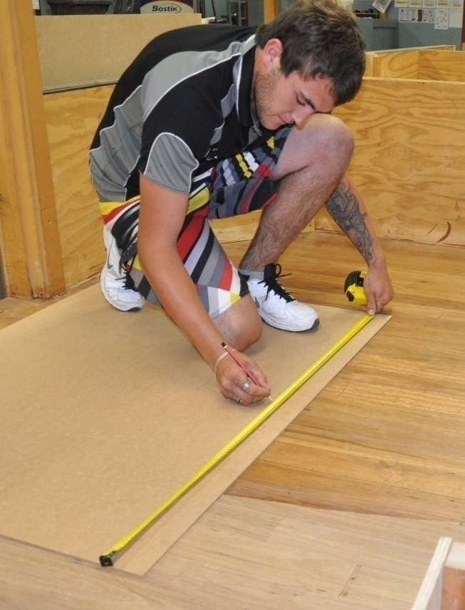
The ability to take accurate measurements and use them in calculations is central to the skills of a floor layer.
Some people find this sort of ‘applied mathematics’ easy. Others need to think more carefully about what they’re doing to avoid making mistakes.
But either way, the types of measurements and calculations that floor layers need to do are very practical, and once you understand the principles you can adapt the techniques to any site-specific situation.
In this unit we’ll look at the mathematical concepts that underpin the work you do with numbers as a floor layer.
Note that we won’t discuss specific types of calculations in detail – these applications are left for the individual units they relate to. However, we will provide the background information you need to know in order to take measurements on-site and use them to solve basic geometric and mathematical questions.

Working through this unit
There are two sections in this unit:
- Calculating
- Measuring.
Each section contains an Overview and a set of Lessons which cover the content material.

Assignments and practical demonstrations
There are no stand-alone assignments for this unit.
Your trainer may use the work you undertake in this learner guide and workbook to count towards your assessment of competence. However, your main assessment tasks will be integrated with the assessment tasks from other competencies in the Certificate III in Flooring Technology that have a particular focus on calculations and measurement.
They may include one of more of the following units covered in the Flooring Technology website project:
- Planning and costing (LMFFL3001A: Plan and cost flooring technology work)
- Subfloor coatings and toppings (LMFFL2102A: Prepare, select and apply smoothing and patching compounds; LMFFL2103A: Select and apply appropriate compounds and additives; LMFFL2105A: Select, prepare and apply moisture barriers and damp proof membranes to concrete sub-floors)
- Lay flat vinyl (LMFFL2301A: Install lay flat vinyl floor coverings)
- Resilient tiles (LMFFL2302A: Install resilient tiles using standard installation practices)
- Commercial vinyl (LMFFL3302A: Install commercial vinyl floor coverings; LMFFL3303A: Install resilient floor coverings using custom designs and decorative finishes.
You will also need to perform a range of practical demonstrations. To help you get ready for these activities, there is a Practical demonstration checklist at the end of Section 2, listing the sorts of things your trainer will be looking for.

Section 1

Calculating

Overview
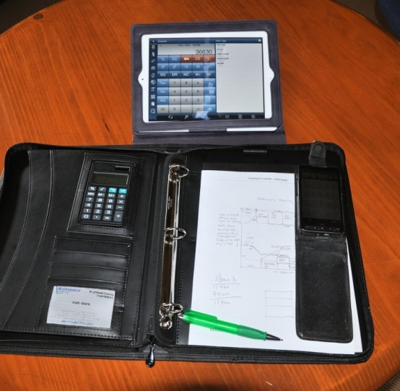
There are some calculations you can do in your head. Counting items and working out simple quantities are calculations that people do all the time, almost without thinking about it. But as the numbers get bigger or more complex, most people need to use a calculator to be sure that they’ve got the right result.
Fortunately, calculators are everywhere these days. You’ll find them in mobile phones, on rulers, in large diaries, and of course as self-contained pocket-sized devices.
In this section, we’ll cover some basic calculations and mathematical procedures that you need to know in order to work with numbers. We’ll also look at the metric system and discuss the terms that apply to various units of measure.

Completing this section
There are five lessons in this section:
- Using a calculator
- Working with fractions
- Decimals and percentages
- The metric system
- Using tallies.
These lessons will provide you with background information to help you with the calculations that we’ll be doing in Section 2.

Using a calculator
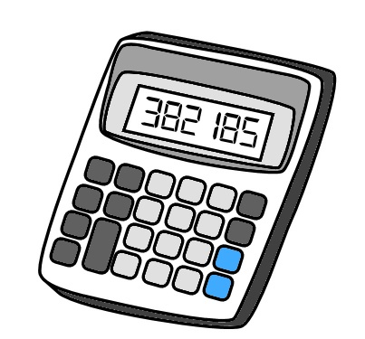
If you’re having trouble using a calculator, the best advice is to read the manufacturer’s instructions. Different calculators operate in different ways, and they don’t always follow the same order for entering numbers and functions.
Here’s a few general hints on how to use a calculator effectively.
1. Clear the calculator before you start any new calculation.
This will ensure that nothing you did before gets mixed up with the calculation you are about to begin.
C
2. Write down the numbers first if they are complicated.
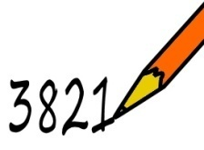
You should also write them down if someone is calling them out to you, such as while taking a series of measurements. Then you can be sure that you’re entering the right numbers, especially if they have decimal points or several zeros.
3. Estimate the answer in your head if the numbers are long or complicated.
This will help you to pick up mistakes, because it will give you an idea of the size of the answer you’re looking for.
4000
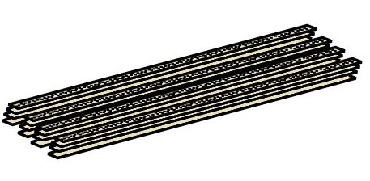
For example, if you had 18 carpet grippers that were each 1.2 metres long, and you wanted to know what the total metreage was, you could do the following calculation in your head:
20 (rounding up 18) x 1 (rounding down 1.2) = 20
So when you do the actual calculation and find that the answer is 21.6 metres, you’ll know that it sounds about right.
The rule of thumb for rounding off numbers is:
Ending in a 5 or more – round up
Ending in a 4 or less – round down

Learning activity 1
Below are some rounding exercises. Write down your answer in the box beside each calculation. When you’ve finished, check your answers in the Answers section at the back.

1. Round off these numbers to the nearest whole number.
6.3

5.2

2. Round off these numbers to the nearest ten.
78

14

3. Round off these numbers to the nearest hundred.
85

530

4. Estimate the answers to these calculations. (You may either do these sums in your head, or use a calculator. But remember to write down your estimated answer, not the actual answer.)
42 x 68

56 x 93

28 x 3.9

7.2 x 2.1

Working with fractions
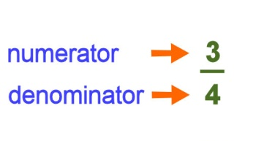
Fractions are made up of two parts. The top part is called the numerator and tells you how many pieces you’ve got. The bottom part is called the denominator and tells you how many pieces make up the whole.
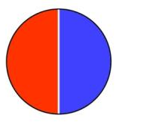
For example, if there are two pieces in the whole, each piece is one half. That is, each piece represents 1 out of 2, or 1/2.
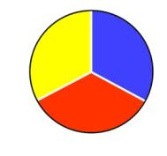
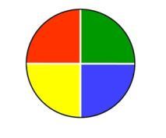
If there are 3 pieces, each one will be a third, or 1/3.
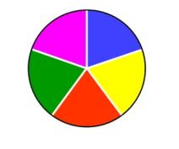
If there are 4 pieces, each will be one quarter, or 1/4.
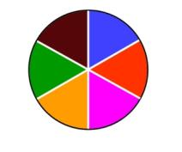
If there are 5 pieces, each will be a fifth, or 1/5.
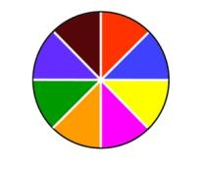
If there are 6 pieces, each will be a sixth, or 1/6.
If there are 8 pieces, each will be an eighth, or 1/8.

Equivalent fractions
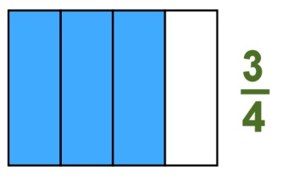
When you divide the same whole into different numbers of pieces, you can write the same proportion in different ways.
For example, this whole is divided into 4 pieces, and 3 of them are shaded blue. In other words, we’ve shaded 3 quarters of the whole, or 3/4.
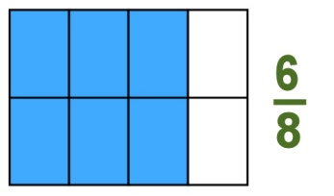
But if we divide the same whole into 8 pieces but still shade the same amount, we’ve now shaded 6 eighths of the whole, or 6/8.
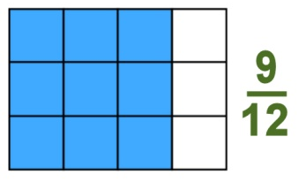
This means that 3/4 is equivalent to 6/8.
If we divide the original whole into 12 pieces, we’ll have shaded 9 pieces. Therefore:
3/4 = 6/8 = 9/12
So if you were presented with the fraction 9/12, how would you know it was really the same proportion as 3/4?
All you need to do is divide the top and bottom of the fraction by the same number. In this case, we know that 3 will divide evenly into both 9 and 12. That is:
9 ÷ 3 = 3
12 ÷ 3 = 4
Another way of writing this is:
9 ÷ 3 3
=
12 ÷ 3 4
We can also run the calculation in reverse by multiplying both halves of the fraction by the same number. That is:
3/4 = 9/12, because:
3 x 3 9
=
4 x 3 12
Note that with some of the fractions shown above, the numerator is on top and the denominator is on the bottom. But the other fractions are written with the numerator and denominator beside each other, separated by the fraction bar. Both of these layouts are common, and it is acceptable to use either. In practice, you’ll probably find that hand-written fractions are easier to write with the numerator above the denominator.

Learning activity 2
Here are some fraction exercises. Write your answers in the boxes provided, and then check them in the Answers section at the back.
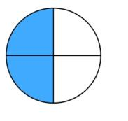
1. Write down the divisions and shaded portions
in this circle as two equivalent fractions.
=
2. Rewrite this fraction as a proportion of 100.
3/10 = /100
3. Rewrite this fraction in its simplest form.
20/50 = /

4. You have two drill bits. The diameter of one is 3/8 inch, and
/ inch

the other is 1/4 inch. Which one will drill the bigger hole?

Decimals and percentages
Now that we’ve looked at how fractions work, let’s see how they relate to decimals and percentages.

From fractions to decimals
The fraction bar is like a division sign. For example, 1/2 is another way of saying: 1÷ 2.
If you do this calculation on your calculator, you will find that it equals 0.5. That is:
1÷ 2 = 0.5
To put it another way, 0.5 is the decimal equivalent of 1/2.
It’s easy to confirm this answer by doing the calculation in reverse. That is, if 1/2 equals 0.5, then 0.5 times 2 should equal 1. You can check this on your calculator:
0.5 x 2 = 1
In the same way, the fraction 1/4 is equivalent to the decimal 0.25. To check whether this is correct, the calculation would be:
1÷ 4 = 0.25
And to double-check it in reverse:
0.25 x 4 = 1

From fractions to percentages
A percentage is simply another way of writing a fraction which has a denominator of 100. Per cent means ‘per 100’, or ‘for every 100’.
For example: 50% = 50/100
We also know that 50/100 = 5/10 = 1/2.
Therefore: 50% = 1/2.
To test it:
50% x 2 = 100%

Here’s another example: 10% = 10/100 = 1/10
To test it:
10% x 10 = 100%

Decimals and percentages
Notice that percentages and decimals are basically the same thing. The only difference is:
- a percentage is a proportion of 100
- a decimal is a proportion of 1.
Therefore:
- to change a decimal to a percentage, multiply by 100
- to change a percentage to a decimal, divide by 100.

Learning activity 3
1. Complete the table below. Then check your answers in the Answers section at the back.

Fraction | Decimal | Percentage
1/100
1/20
1/10
1/8
1/5
1/4
1/2
1

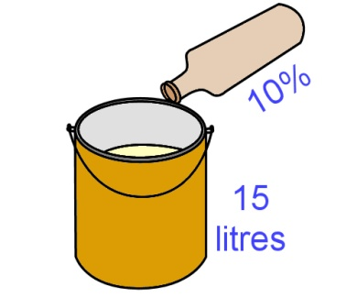
2. Let’s say you have 15 litres of a coating product and you’re going to apply it with a spray gun. The manufacturer’s advice is to add 10% thinners to the coating to improve the flow. How many litres of thinners should you add?
litres

3. If you earned $800 per week and paid 30% in tax, how much tax would you pay each week?
$

The metric system
Before the 1970s, the units of measure used in Australia generally came from the imperial system. This was a reference to ‘imperial’ Britain, because that’s where the system was first developed. Length, for example, was measured in inches, feet, yards and miles. Weight was measured in ounces, pounds, stone and tons.
However, between the 1970s and 1980s Australia progressively converted its measurement units across to the International System of Units – called the ‘SI’ (an abbreviation of the French ‘Système International’). This is commonly referred to as the metric system.
The metric system is based on the decimal system of numbers. This means that all measurement units are based on multiples of 10.
For example, the standard unit of length is the metre. So the other units used to denote longer and shorter lengths are in multiples of 10 from the ‘one metre’ standard. Set out below is the table of metric length units ranging from the millimetre (mm) to the kilometre (km).
Length | Abbreviation | Proportion  of 1 metre | Some typical uses
1 millimetre | mm | 1/000 or 0.001 | Building and manufacturing
1 centimetre | cm | 1/100 or 0.01 | Dressmaking
1 decimetre | dm | 1/10 or 0.1 | Log diameters
1 metre | m | 1 | Standard unit of length
1 decametre | dam | 10 | Meteorology
1 hectometre | hm | 100 | Surveying
1 kilometre | km | 1000 | Distance measurement

As you look down this list of terms, you’ll probably notice that not all of these units are commonly used.
Metres and kilometres are terms used by just about everyone, including in ordinary day-to-day conversations. Millimetres are widely used in building, construction and manufacturing. Centimetres are also common in particular fields. But decimetres, decametres and hectometres have only limited usage in specialist areas.
Nonetheless, the prefix (first half of the term) of each of these units is very handy to know, because it tells you what the quantity is in relation to the standard unit of measure, whatever it is that you’re measuring. For example:
Milli always means 1/1000, so:
- 1 millimetre (mm) is 1/1000 of 1 metre (m)
- 1 millilitre (mL) is 1/000 of 1 litre (L)
- 1 milligram (mg) is 1/1000 of 1 gram (g)
Kilo always means 1000, so:
- 1 kilometre (km) is 1000 metres
- 1 kilolitre (kL) is 1000 litres
- 1 kilogram (kg) is 1000 grams.

Learning activity 4
On the following page is a table showing various lengths in kilometres (km) centimetres (cm) and millimetres (mm). Rewrite each of these measurements in metres, or proportions of a metre.
Remember that the decimal point is critical in metric measurements. If you’re not sure where the point should go, refer back to the table of metric measurements above.
It’s also good practice to put a zero in front of the decimal point if the number is less than 1. That is, it’s better to write ‘0.5’ than ‘.5’, because there is less chance of misreading the measurement when you come back to it later.
Check your answers in the Answers section at the back.

Length | Length in metres
1.5 km | m
1 km | m
1/2 km | m
1/4 km | m
350 cm | m
185 cm | m
4800 mm | m
3660 mm | m
900 mm | m
255 mm | m
75 mm | m
25 mm | m
9 mm | m
3 mm | m

Using tallies
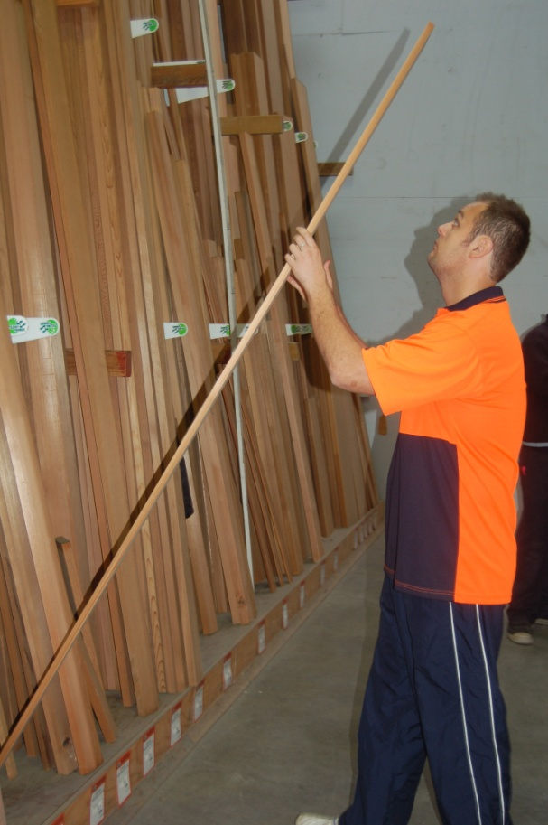
Tallies are used to record quantities of particular items or products. For instance, if you wanted to write down how many power tools you had taken onto a jobsite, your tally might read:
1 x jigsaw; 1 x circular saw; 3 x cordless drills; 2 x claw hammers ... and so on.
But if you had a product that was already expressed in terms of its cross-section size, such as 70 x 19 skirting board, it would get very confusing if you started to use the ‘x’ (‘times’) sign to also indicate the number and length of the pieces.
Set out below are some examples of how to record tallies when you’re working with items that are referred to by their cross sectional dimensions.

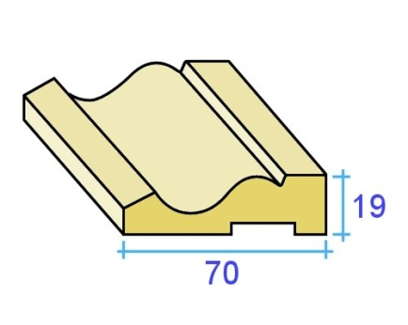
Example 1: skirting boards
Let’s say you have 15 pieces of skirting board,
70 mm x 19 mm in size. We’ll say that 5 pieces are
2.4 metres in length, 7 pieces are 2.7 metres and
3 pieces are 3.6 metres.
To show this as a tally, you would write:
70 x 19 skirting: 5/2.4, 7/2.7, 3/3.6
Now let’s say we wanted to know how many lineal metres this tally represents. Note that ‘lineal’ means ‘in a line’ – so to put the question another way: What is the total metreage of these pieces if they were all laid out in a line?
The easiest way to find the answer is to use a calculator with a memory button. Remember that not all calculators work in exactly the same way, but the sequence of numbers and function buttons you’d press would be something like this:
Clear memory – make sure the memory is clear before you start.
CM
Clear all – make sure the input is also clear
C
5 x 2.4 5 pieces times 2.4 metres in length, add to Memory plus subtotal
M+
7 x 2.7 7 pieces times 2.7 metres in length, add to Memory plus subtotal
M+
3 x 3.6 3 pieces times 3.6 metres in length, add to Memory plus subtotal.
M+
Read memory – read the total in the memory.
RM
If you don’t have a calculator with a memory button, you can simply multiply each line separately and then add the subtotals together. The mathematical way of writing up this calculation is:
(5 x 2.4) + (7 x 2.7) + (3 x 3.6) = 41.7

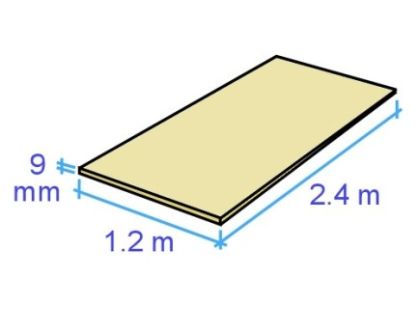
Example 2: plywood sheets
Sheet materials sometimes have their dimensions shown in metres and sometimes in millimetres.
For example, if you had two sheets of ply that were
9 mm thick, 2.4 metres long and 1.2 metres wide,
it could be written up as:
9 mm ply: 2 / 2.4 x 1.2
or alternatively
9 mm ply: 2 / 2400 x 1200

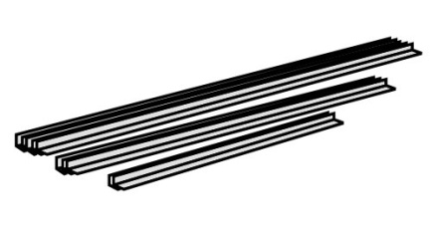
Learning activity 5
How many lineal metres (l/m) are in this bundle of aluminium angle lengths?
19 x 12 aluminium angle:
5/3.0, 3/2.4, 2/1.8
l/m
Check your answers in the Answers section at the back.

Section 2

Measuring

Overview
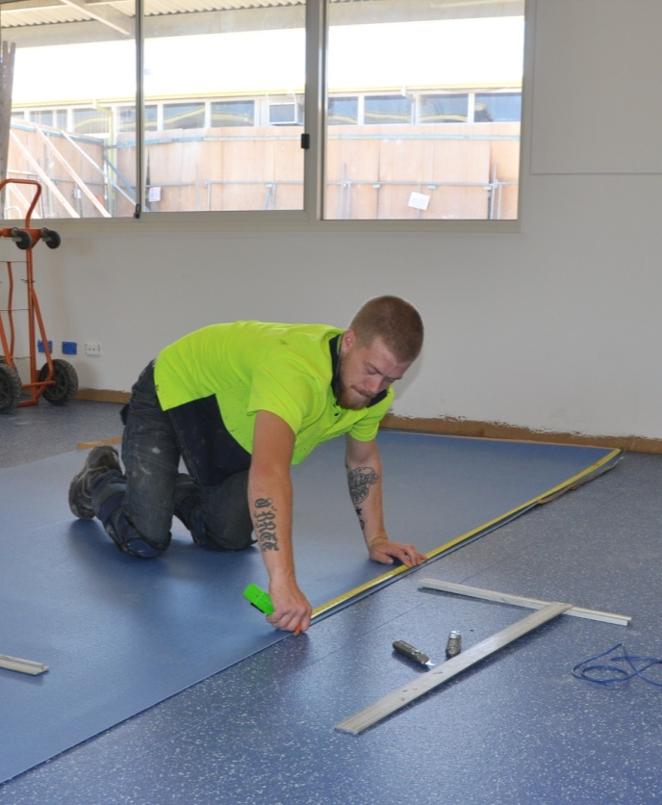
Now that we’ve covered the main terms used in the metric system and looked at the relationship between fractions, decimals and percentages, it’s time to apply these principles to some workplace calculations.
In this section, we’ll start with measurements of length, and work up
to volume calculations for three dimensional shapes. We’ll also talk about methods of checking angles.
And we’ll introduce some of the measuring instruments used in laying floor coverings and discuss ways of making sure that the measurements you take with them are reliable and accurate.

Completing this section
There are five lessons in this section:
- Length
- Area
- Angles
- Volume
- Avoiding errors.
These lessons provide background information that will help you with the integrated assessments you undertake when you complete other units in your course.

Length
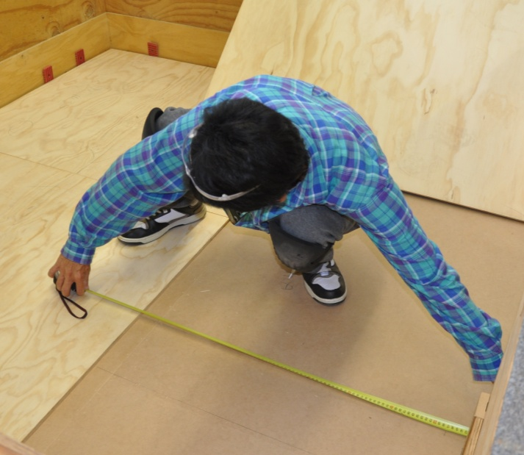
In Section 1 we talked about the metric system, and used the units of length to show how the different prefixes relate to each other – such as kilo-, deci-, centi- and milli-.
Floor layers use millimetres for most measurements. However, this hasn’t always been the case – see ‘Understanding measurements’ in the unit Planning and costing for more details on the different units of measure that are used in floor laying.
In cases where thicknesses of less than a millimetre are used, such as when manufacturers state the thickness of a flooring product’s wear layer, the unit of measure often used is the micrometre.
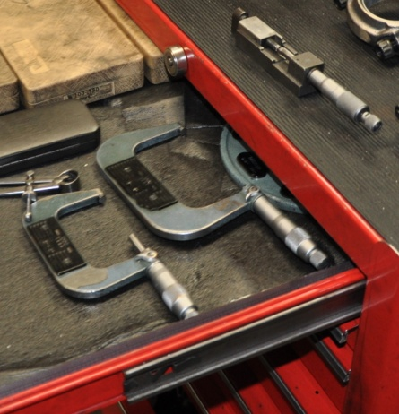
One micrometre is 1/1,000,000 (one millionth) of a metre, or 1/1,000 (one thousandth) of a millimetre. Its symbol is ‘µm’, which is sometimes written as ‘um’.
Many people prefer to use the old fashioned term micron instead of micrometre. This is designed to avoid confusion with the measuring device called the micrometer, although strictly speaking 'micron' is no longer officially recognised as a term under the SI system.
In practice, micrometres are often expressed as millimetres to several decimal places. For example, 500 µm might simply be referred to as 0.5 mm, and 50 µm would be 0.05 mm

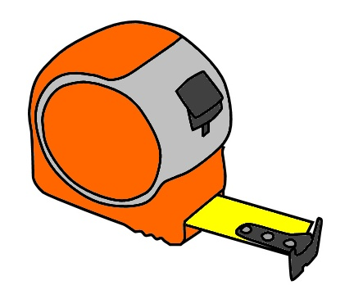
Measuring devices
The most common general-purpose measuring device is the tape measure.
Spring loaded retractable tape measures range in length from tiny 1 metre tapes to the standard 7 to 8 metre tradesperson’s tape.
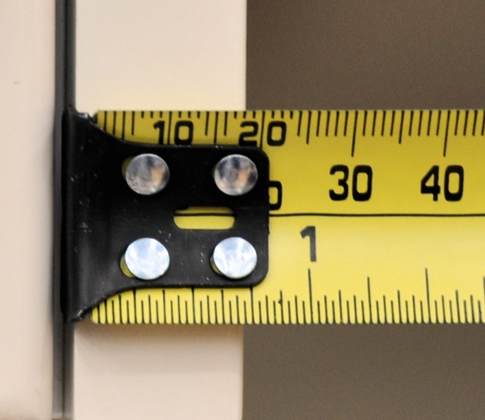
When you look closely at the end of a normal retractable tape, you’ll notice that the steel hook is secured with rivets, with a bit of play in the holes allowing it to move back and forth. The amount of movement allowed is the same as the thickness of the hook.
Its purpose is to compensate for the hook thickness when you either push the tape up against an object for an inside measurement or hook it over the object for an outside measurement.
Other common measuring devices are as follows:
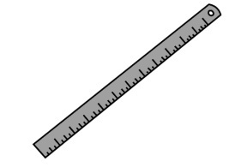 | Steel rule – very rugged, good for fine measurements, able to be used as a straight edge.
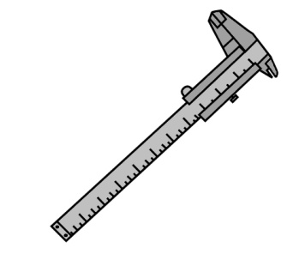 | Vernier caliper – used for measuring thicknesses and diameters very precisely, in some cases to an accuracy of 10 micrometres, or 0.01 mm.
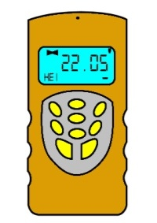 | Laser distance meter – measures digitally with a laser beam; can be either hand held or combined with a laser level.

Learning activity 6
Below are four segments of a tape measure, together with an arrow pointing to a particular length. See if you can write down the correct length in millimetres for each one.
Don’t be fooled – some of these are harder than they look! Remember, you’ll need to take into account the units of measure, and on two of the segments, the previous markings on the left hand side that aren’t visible.
This is good practice for the times when you’re actually using a tape measure on the job, especially when you’re measuring long lengths. It takes concentration to read off the correct measurement without misreading the position of the graduations on the tape.
Write your answers in the boxes provided. When you’ve finished, check your answers in the Answers section at the back.
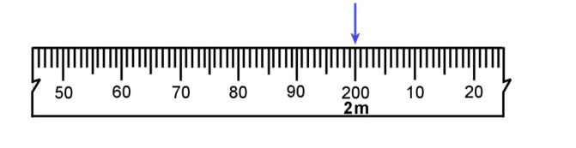  1. | mm
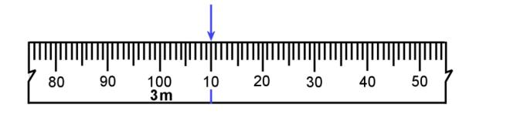  2. | mm
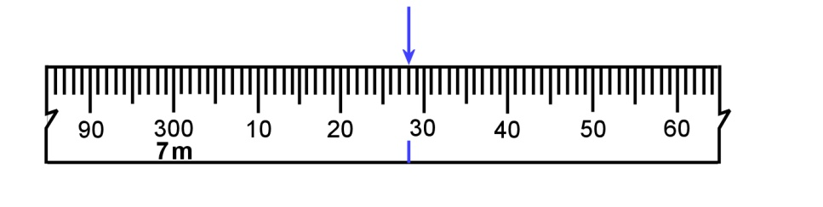  3. | mm
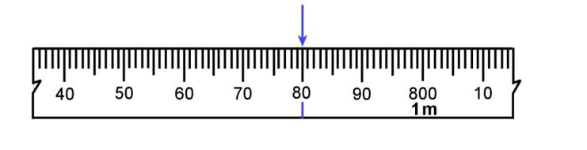  4. | mm
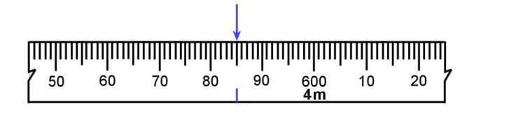  5. | mm

Area
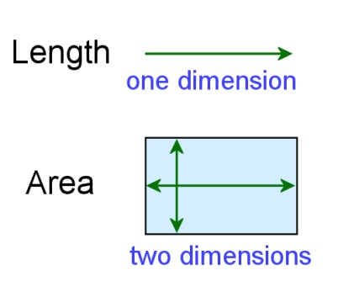
If you think of length as being one dimensional, that is, going in one direction only, then area is two dimensional, because it has length and width.
Let’s have a look at the area of some common shapes.

Squares and rectangles
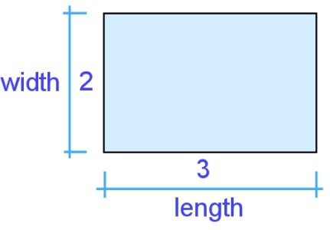
The area of any square or rectangle is simply its length times its width. For example, if a rectangle is 3 metres long and 2 metres wide, its area is:
Length x width = 3 m x 2 m = 6 square metres (m²)
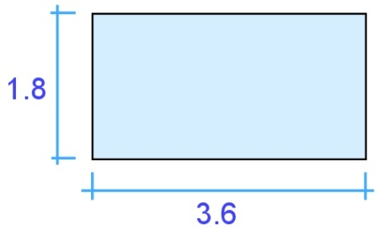
What if you had a sheet of particle board measuring 3.6 m x 1.8 m? Its area is simply:
Length x width = 3.6 m x 1.8 m = 6.48 m²

Triangles
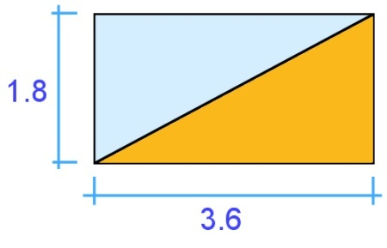
Let’s say you cut the sheet of particle board in half diagonally, forming two equal triangles. The area of each triangle is exactly half of the original rectangle. That is:
Length x height ÷ 2 = 3.6 x 1.8 ÷ 2 = 3.24 m²
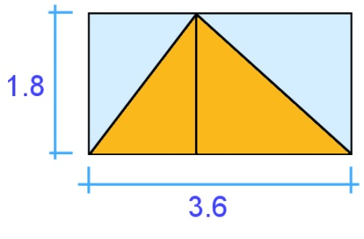
This proves that a triangle is half the area of the rectangle or square that it came from. So even if you had a triangle that didn’t have a right angle in it, the calculation is still the same, because you could simply divide the triangle into 2 triangles, and the rectangle around it into 2 rectangles.
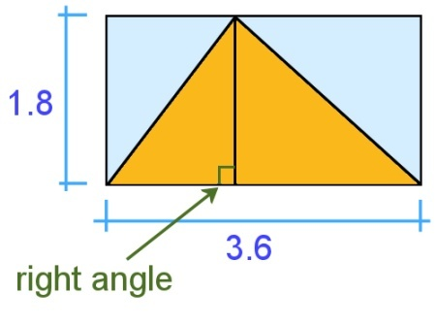
But note that you must always measure the height of the triangle at right angles (90 degrees) to the base.
You can’t measure the diagonal line in the triangle, because that’s not the true height of the rectangle that goes around it.

Circles
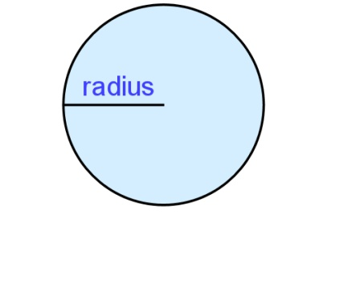
You may remember from your school days that the formula for the area of a circle is: π r ², where π (called ‘pi’) is 3.14, and ‘r’ is the radius of the circle.
If you’re happy using that formula you can stay with it, but you might prefer this simplified version – which is actually the same, but just put in different terms:
Area of a circle = diameter x diameter x 3.14
2 2
Another way of writing this is:
Area = (diameter ÷ 2) x (diameter ÷ 2) x 3.14
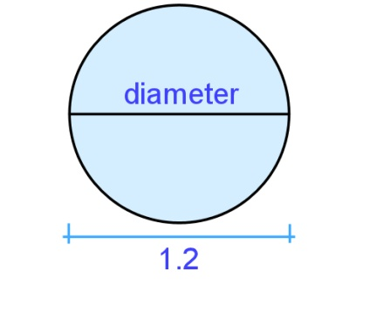
Here’s an example. If a circle is 1.2 m in diameter, what’s its area? The answer is:
Area = (diameter ÷ 2) x (diameter ÷ 2) x 3.14
= (1.2 ÷ 2) x (1.2 ÷ 2) x 3.14
= 0.6 x 0.6 x 3.14
= 1.13 m²

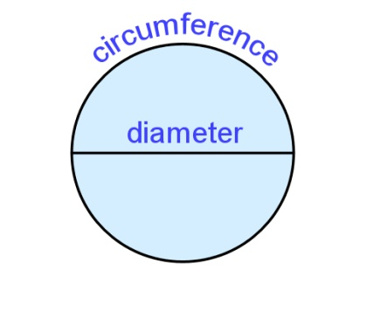
So where does 3.14 come from? This is actually the approximate ratio between the circumference, or outside measurement, of the circle and its diameter. In other words, the circumference of a circle is about 3.14 times longer than its diameter.
When ‘pi’ is used in this formula it has the effect of helping to shrink the area of the square that goes around the circle down to the area of the circle itself.

Compound shapes
If you can break a shape up into its basic parts, you can calculate its area by adding the separate areas together. Here’s three examples.

Example 1: L shape
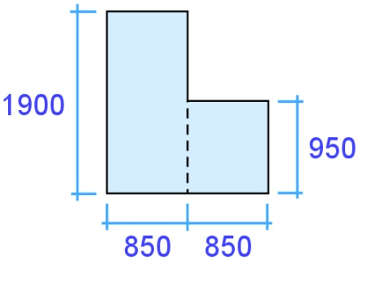
This L shape is basically two rectangles. What is its area? Note that the measurements in the diagram are shown in millimetres, so you’ll need to convert them into metres for the calculation.
Rectangle 1: 1.9 x 0.85 = 1.615 m²
Rectangle 2: 0.95 x 0.85 = 0.808 m²
Total area: 1.615 + 0.808 = 2.423 m²
Written mathematically, this would be: (1.9 x 0.85) + (0.95 x 0.85) = 2.423 m²

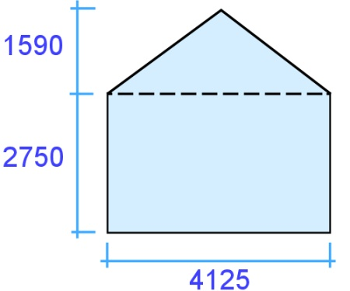
Example 2: Gable end of a house
This shape is a triangle plus a rectangle
Triangle: 1.59 x 4.125 ÷ 2 = 3.279 m²
Rectangle: 2.75 x 4.125 = 17.05 m²
Total area: 5.58 + 17.05 = 22.63 m²
Written mathematically: (1.8 x 6.2 ÷ 2) + (6.2 x 2.75) = 22.63 m²

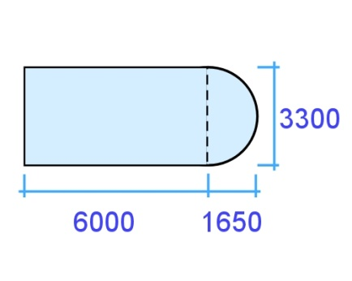
Example 3: Half circle around a bay window
This floor area is made up of a rectangle and a semicircle.
The formula for finding the area of a semicircle is simply:
Semicircle area = area of circle ÷ 2.

In other words:
Semicircle area = (diameter ÷ 2) x (diameter ÷ 2) x 3.14 ÷ 2
= (3.3 ÷ 2) x (3.3 ÷ 2) x 3.14 ÷ 2
= 1.65 x 1.65 x 3.14 ÷ 2
= 4.274 m²
Now we can do the rest of the calculation:
Rectangle: 6.0 x 3.3 = 19.8 m²
Total area: 4.274 + 19.8 = 24.074 m²
Written mathematically: (3.3 ÷ 2 x 3.3 ÷ 2 x 3.14 ÷ 2) + (6.0 x 3.3) = 24.074 m²

Learning activity 7
You have been asked to measure up the floor area of the house shown below.
What is the total area in square metres?
m²
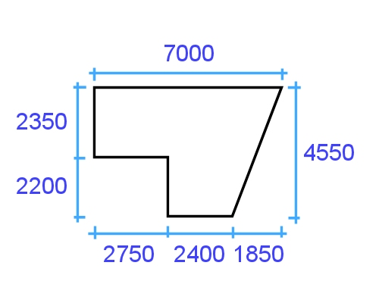

Angles
When two straight lines meet, they form an angle between them. If the lines are walls in a square room, or the sides of a square box, they will form a right angle.
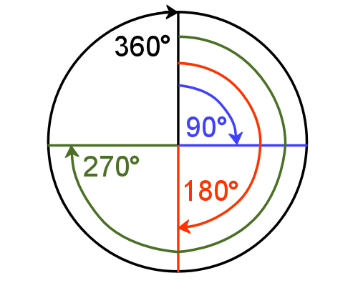
Another way of referring to a right angle is to say it is 90° (degrees). This is a reference to the amount of turn between the 2 lines.
That is, if you had a circle and drew a radius from the middle to the top, and then rotated it one quarter of a turn, you would have turned the radius through 90°.
One full turn around a circle is 360°. This means that every angle formed between the two lines will be something less than that – for example, one quarter is 90°, half is 180°, three quarters is 270°.

Setting out and marking lines at angles
The most common tools used by flooring installers to draw lines, set out angles and guide a utility knife while cutting are as follows.

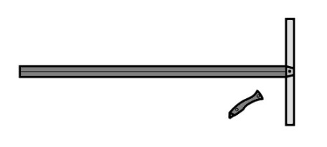 | Straight edge square, used for long lines at right angles to an edge.
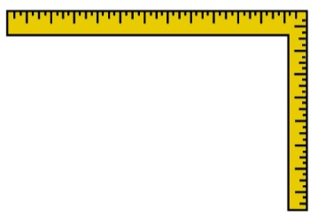 | Carpenter’s square, also called a builder’s square, used for right angles and for measuring.
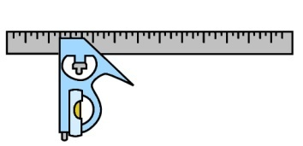 | Combination square, which allows you to set out and measure lines at 90° and 45°.
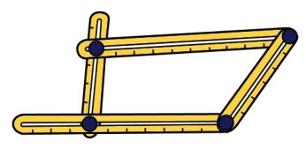 | Template tool, which can be used to transfer angles from the installation area onto the floor covering material.

Using a level
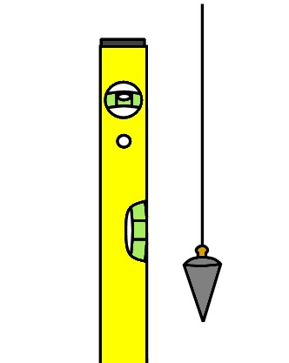
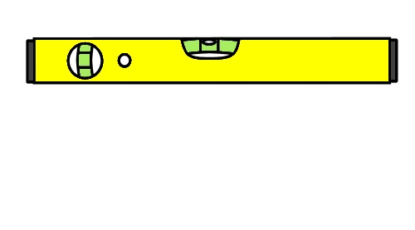
Level means perfectly horizontal. A spirit level allows you to check that a surface or line is horizontal. It works on the principle that the bubble will find the highest point in a glass tube, because it is lighter that the surrounding fluid.
Since the tube is curved slightly with the highest point in the middle, the bubble floats exactly in the middle when the level is horizontal.
You can also use a level to check whether a surface or line is plumb. ‘Plumb’ means perfectly vertical, and comes from a Latin word meaning ‘lead’. This is a reference to the plumb bob, which traditionally was always made of lead.
When a plumb bob is hung from a string, gravity draws the weight downwards, and the string forms a vertical line.

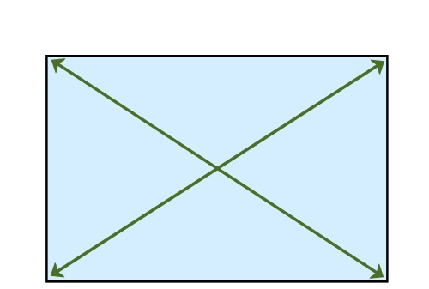
Measuring diagonals
One way of checking to see whether a square or rectangular shape has right angled corners is to measure the diagonals.
This principle works because the opposite sides of a square or rectangle are always parallel – that is, the same distance apart at both ends. Therefore, if the corners are at 90°, or ‘square’, the two diagonals will be the same length.
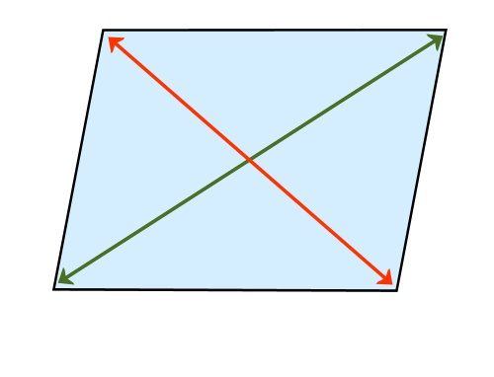
If the diagonals are not the same length, then the corners can’t be square, even if the sides are still parallel.
It’s worth keeping this in mind as a reminder that you can’t simply measure the lengths of the sides to check that a shape or area is square – this won’t tell you whether the corners are at right angles.

Using the 3, 4, 5 rule
Another way of checking a corner for square is to use the 3, 4, 5 rule. This is an application of an old formula that Pythagoras, the ancient Greek philosopher, came up with over 2,500 years ago.
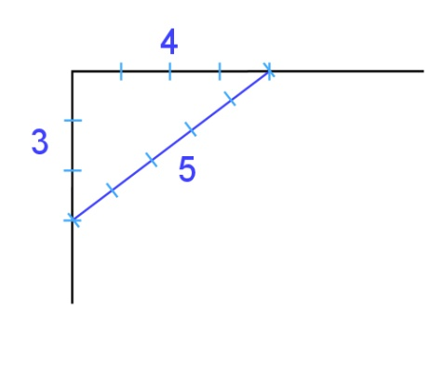
Let’s say you wanted to check whether the walls in the corner of a room were square, but it was a big open-plan room that didn’t have opposite corners to measure.
The 3, 4, 5 rule states that if you measure 3 units along one wall and mark the point, and 4 units along the other wall and mark the point, the distance between the two points will be 5 units if the corner is square.
It doesn’t matter what length a ‘unit’ is, as long as the proportions are 3, 4 and 5. That is, your lengths could be 3 metres, 4 metres, 5 metres; or 3 feet, 4 feet, 5 feet; or 6, 8, 10 or any other multiple of 3, 4, 5.

Learning activity 8
The drawing below shows one corner of a room. The floor layer measures 1500 mm from the corner along one wall and marks the point. Then he marks 2000 mm from the corner along the other wall.
What length will the diagonal line be if the corner is square?
mm
Check your answer in the Answers section at the back.
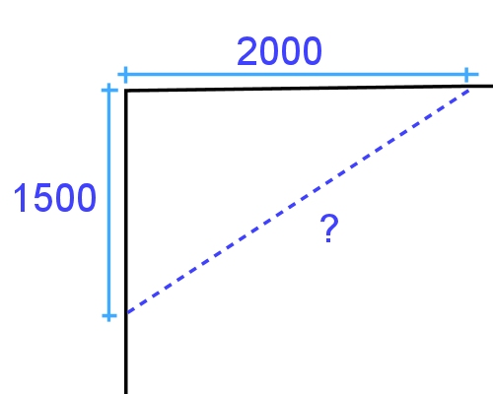

Volume
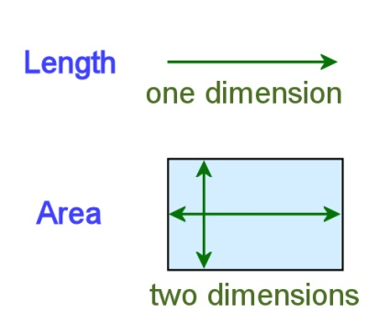
So far we’ve described length as being one dimensional and area as two dimensional. But for an object to take up space in the real world it needs a third dimension. Volume is a way of measuring three dimensional space.
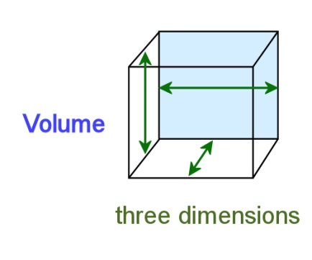
We know that if a square measures one metre by one metre, it will have an area of one square metre (m²).
If we now give it a depth of one metre, it will have a volume of one cubic metre (m³). This is the standard unit of volume in the SI metric system.
Large objects, building materials and spaces are often measured in cubic metres. But a more common measure for fluids and the capacity of containers is litres (L).
Here are some metric volume measurements:
1 cubic metre (m³) = 1,000 litres (L) = 1,000,000 cubic centimetres (cm³)
1 L = 1,000 millilitres (mL) = 1,000 cm³
1 mL = 1 cm³
Let’s apply these units of volume to some typical examples.

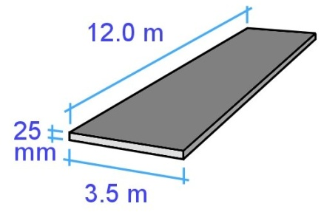
Example 1: Concrete slab
How much cement-based filler do you need to lay on top of a concrete subfloor if the average thickness is going to be 25 mm and the slab measures 12 m by
3.5 m?
Notice that there is a combination of units here – the length and width are in metres and the thickness is in millimetres. So the first thing we need to do is convert the thickness to metres: 25 mm = 0.025 cm³
Now we can do the calculation.
Volume = length x width x thickness
= 12 m x 3.5 m x 0.025 m
= 1.05 m³
In practice, you might add 10% to cover variations in the original subfloor level which will affect the thickness of your filler. So in this case you would add 0.105 m³ to the total.

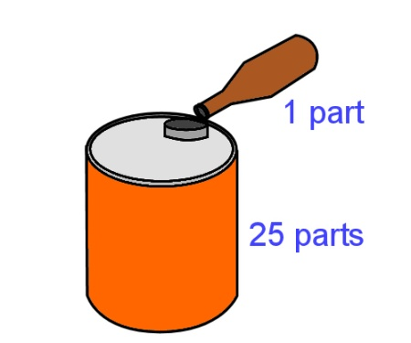
Example 2: 2-stroke fuel
A common petrol:oil ratio for 2-stroke engines is 25:1. This means that for every 25 parts of petrol you need to mix in 1 part of 2-stroke oil.
If you had a 4 litre container of petrol, how much oil do you need to add?
We know that:
1 L = 1000 mL, so
4 L = 4,000 mL.
Therefore:
4,000 mL (petrol) ÷ 25 = 160 mL (2-stroke oil).

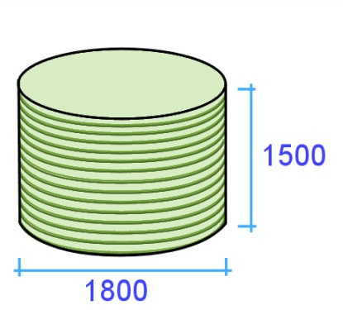
Example 3: Water tank
How much water can a tank hold with a diameter of
1800 mm and a height of 1500 mm?
Cylinder volume = area of circle (cross section) x height
= diameter x diameter x 3.14 x height
2 2
= 1.8 ÷ 2 x 1.8 ÷ 2 x 3.14 x 1.5
= 0.9 x 0.9 x 3.14 x 1.5
= 3.815 m³
Since there are 1000 litres in 1 m³, the volume in litres is:
3.815 m³ x 1000 = 3815 L

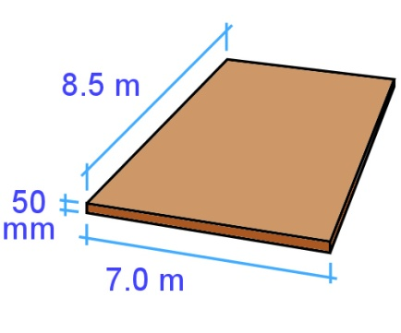
Learning activity 9
- You are landscaping your front yard and have decided to spread topsoil over the lawn area. The topsoil will be an average of 50 mm thick, and needs to cover an area of 7 metres by 8.5 metres.
How much topsoil will you need?
m (thickness)
m (width)
m (length)
Volume of topsoil: = x x
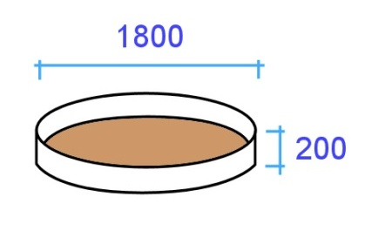
=
m³
2. You also want to put a water feature pond at one end of the yard. The pond will be round, with a diameter of 1.8 metres. The depth will be 200 mm. How much water will the pond hold when it is full?

Surface area of pond = ÷ 2 x ÷ 2 x 3.14
m (diameter)
m (diameter)
=
m²

Volume of pond in m³ = x
m (depth)
m² (surface area)
=
m³

Volume of pond in litres = x 1000 =
m³
L

Check your answers in the Answers section at the back.

Avoiding errors
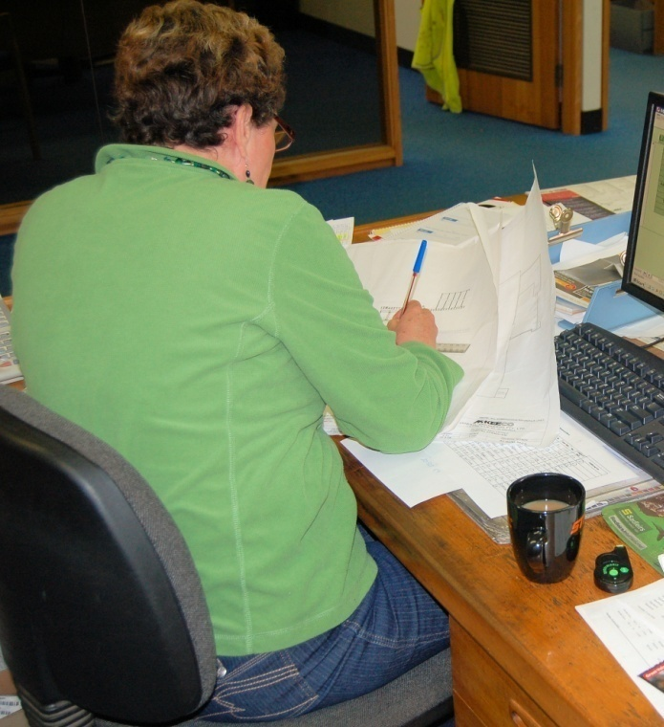
Throughout this unit we’ve touched on a few issues that can cause errors in measurements and calculations. The suggestions we’ve provided so far for avoiding errors include:
- estimating the answers you would expect to see in a calculation, so that if there is a glaring error you can pick it up more easily
- writing down the numbers first, especially if someone else is calling them out to you, so that you have a written record of the measurements or quantities
- reading the numbers and graduations carefully on a tape measure, to make sure that you are taking off the correct measurement from the correct section of the tape.
Below are some more suggestions for making sure that the measurements you take are accurate and correct.

Reading dials and gauges
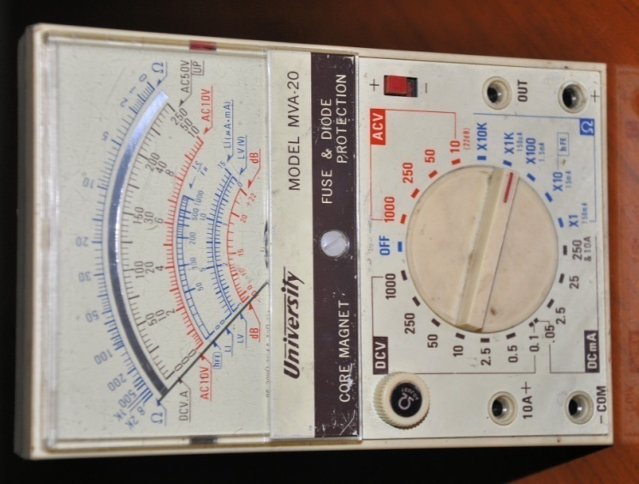
A common error when reading dials or gauges is to look at the pointer from an angle to the scale. This means that instead of reading off the mark immediately behind the pointer, you read a mark that is either on the left or right hand side of the pointer.
The problem is called parallax error, because ‘parallax’ refers to the way an object seems to change its position when your own point of observation changes.
Some instruments have a mirror on the dial so that you can line up the pointer with its own reflection, to make sure that your reading is exactly at right angles to the scale. Even if there isn’t a mirror, the simple solution to the problem is to use one eye only and make sure you’re looking at the scale at exactly 90 degrees.
It is even possible to get a parallax error with a ruler or tape measure if the graduations are not hard against the mark or edge that you want to measure. Again, always make sure that your eye is at 90 degrees to the scale when you take the measurement. In the case of the tape measure, you should also push down the steel blade so that the top edge is flat against the object you’re measuring.

Calibrating instruments
Some measuring instruments need to be calibrated before they are used. This often means resetting the zero mark or testing the instrument against a benchmark reading.
Some instruments also need to be adjusted differently for particular types of materials.
For example, moisture meters for timber use different scales depending on the species of hardwood or softwood being measured.
The simplest way of making these sorts of allowances is to have a conversion chart that enables the user to add or subtract amounts to give a ‘corrected’ reading.

‘Measure twice, cut once’
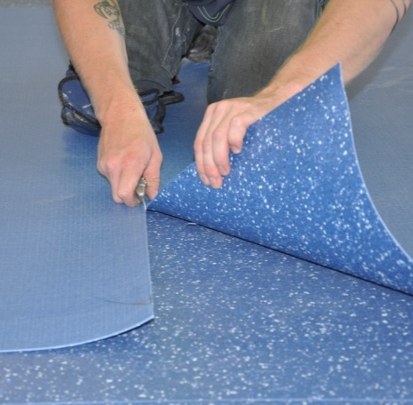
This is an old saying that just about every apprentice or worker has heard from their boss. It’s a good saying, because it’s a little reminder that simple mistakes can happen any time, and they’re easy to fix if all that’s needed is another quick check.
But once you’ve cut the piece or committed yourself in some other way to the measurement you’ve just taken, it may end up being a very big mistake if your measurement turned out to be wrong.
In that sense, the extra time taken to double-check a measurement or calculation is time very well spent, because at the very least it will give you the confidence that you were right the first time. And if it does happen that your second reading is different from the first one, you’ll have given yourself a get-out-of-jail-free card, because you can immediately correct the error before it causes you any grief or expense.

Learning activity 10
Choose one measuring instrument that requires calibration, or setting to zero, before it is used. Answer the following questions:
  - What is the instrument called?

  - What does it measure?

  - Describe the process of calibrating the instrument?

  - What would happen if you took a measurement when the instrument was not calibrated correctly?

If you don’t know enough about a particular instrument to answer these questions, ask your supervisor or trainer for help. See if you can get the instruction booklet for the device you have chosen and do some research. Best of all, ask someone to carry out the calibration process with you and explain the finer details.

Practical demonstration
The checklist sets out the sorts of things your trainer will be looking for when you undertake the practical demonstrations for this unit. Make sure you talk to your trainer or supervisor about any of the details that you don’t understand, or aren’t ready to demonstrate, before the assessment event is organised. This will give you time to get the hang of the tasks you will need to perform, so that you’ll feel more confident when the time comes to be assessed.
When you are able to tick all of the YES boxes below you will be ready to carry out the practical demonstration component of this unit.

Practical demonstration checklist
You will be asked to select a range of measuring devices or instruments that you use at work and demonstrate your ability to use each one competently. Your trainer will need to see you carry out these activities over a period of time, to make sure that you are satisfying these ‘demonstration criteria’ consistently under different conditions.
Demonstration criteria | YES
- Describes the purpose of the measuring device and the units of measure it uses.
- Checks the device for faults and identifies the parts that are most prone to malfunction.
- Where required, checks that the device is correctly calibrated.
- Uses the device to measure a range of items and demonstrates the process of checking that the measurements are reliable and accurate.
- Explains any external factors that need to be taken into account, such as temperature, humidity, or changing conditions in the item being measured.
- Carries out any necessary calculations relating to the measurements taken.
- Records the results correctly, using the appropriate symbols and abbreviations.
- Describes the process of reporting faults and dealing with malfunctions.

Answers to Learning activities

Learning activity 1
1. 6.3 6
5.2 5
2. 78 80
14 10
3. 85 100
530 500
4. 42 x 68 40 x 70 = 2800
56 x 93 60 x 90 = 5400
28 x 3.9 30 x 4 = 120
7.2 x 2.1 7 x 2 = 14

Learning activity 2
1. 1/2 = 2/4
Proof: 1 x 2 = 2
2 x 2 4
2. 30/100
Proof: 3 x 10 = 30
10 x 10 100
3. 20/50 = 2/5
Proof: 20 ÷ 10 = 2
50 ÷ 10 5
4. 3/8 inch will be bigger, because the other drill bit is 1 x 2 = 2
4 x 2 8

Learning activity 3
1.
Fraction | Decimal | Percentage
1/100 | 0.01 | 1%
1/20 | 0.05 | 5%
1/10 | 0.1 | 10%
1/8 | 0.125 | 12.5%
1/5 | 0.2 | 20%
1/4 | 0.25 | 25%
1/2 | 0.5 | 50%
1 | 1.0 | 100%

2. 10% = 1/10 = 0.1
Therefore:
15 (litres) x 0.1 (thinners) = 1.5 litres

3. 30% = 30/100 = 0.3
Therefore:
$800 (wage) x 0.3 (tax) = $240

Learning activity 4
Length | Length in metres
1.5 km | 1500 m
1 km | 1000 m
1/2 km | 500 m
1/4 km | 250 m
350 cm | 3.5 m
185 cm | 1.85 m
4800 mm | 4.8 m
3660 mm | 3.66 m
900 mm | 0.9 m
255 mm | 0.255 m
75 mm | 0.075 m
25 mm | 0.025 m
9 mm | 0.009 m
3 mm | 0.003 m

Learning activity 5
5/3.0, 3/2.4, 2/1.8 = 25.8 l/m

Learning activity 6
1. | 2200 mm
2. | 3110 mm
3. | 7328 mm
4. | 1780 mm
5. | 4585 mm

Learning activity 7
The total area of the floor will be:
(2.35 x 2.75) + (2.4 x 4.55) + (1.85 x 4.55 ÷ 2)
= 6.463 + 10.92 + 4.209
= 21.592 m²

Learning activity 8
The diagonal length will be 2500 mm. This is because the ratio of 1500 : 2000 : 2500 is the same as 3 : 4 : 5.
You can do this in your head by multiplying 3, 4 and 5 by 1000 (3000, 4000, 5000) and then halving each number

Learning activity 9
1. Volume of topsoil: 7 (length) x 8.5 (width) x 0.05 (thickness) = 2.975 m³
You could round this up to 3 m³
2. Surface area of pond = 1.8 (dia.) ÷ 2 x 1.8 (dia.) ÷ 2 x 3.14 = 2.543 m²
Volume of pond in m³ = 2.543 (m² surface area) x 0.2 depth = 0.509 m³
Volume of pond in litres = 0.509 m³ x 1000 = 509 L

Learning activity 10
Answers will depend on the instrument chosen.

