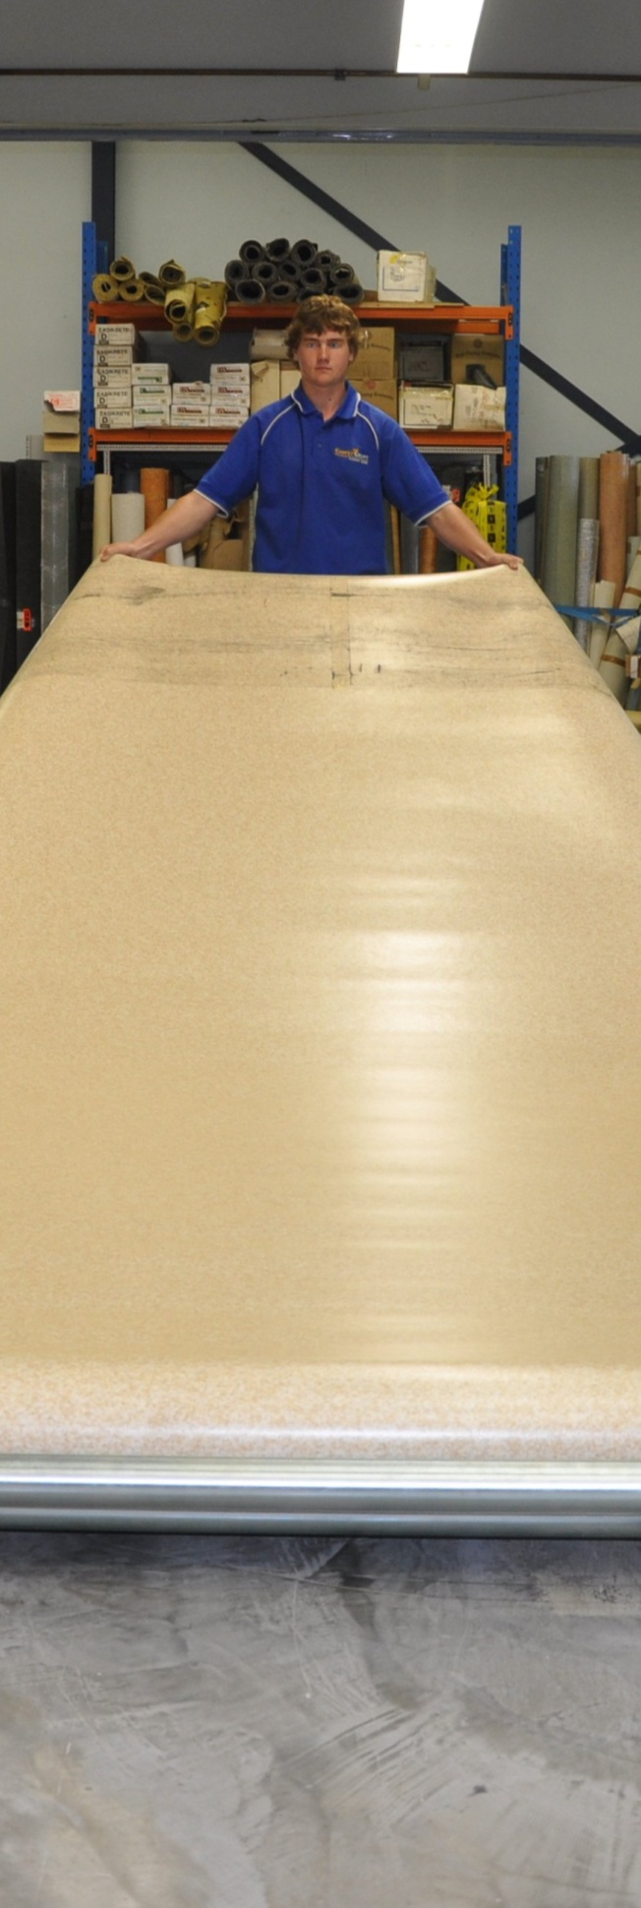
Linoleum
DRAFT VERSION
October 11
Workbook
Supporting:
LMFFL3301A: Install
linoleum floor coverings
Name:

Linoleum

Workbook

Containing learning activities and assignments for the unit of competency:
LMFFL3301A: Install linoleum floor coverings

The assignment templates are also available in an electronic ‘Word’ version, downloadable from the Flooring technology website at:
www.flooringtech.com.au

Developed by Workspace Training for the 2012-2013
Workplace English Language and Literacy (WELL) Program
Flooring Technology resource development project

ISBN: 978-1-925087-04-8
Funded under the Workplace English Language and Literacy Program by the Australian Government through the Department of Industry, Innovation, Climate Change, Science, Research and Tertiary Education
© Commonwealth of Australia 2013

CC BY-NC-SA

This work is copyright. Except where otherwise indicated, and save for the Commonwealth Coat of Arms, the Department has applied the Creative Commons Attribution-Noncommercial-Share Alike 3.0 Australia Licence to this work.
The Department of Industry, Innovation, Climate Change, Science, Research and Tertiary Education must be attributed as the author of the Department’s copyright material.
As far as practicable, material for which the copyright is owned by a third party has been clearly labelled. The Department has made all reasonable efforts to ensure that this material has been reproduced in the print-based resources and accompanying website with the full consent of the copyright owners.
Requests and enquiries concerning the Department’s copyright material should be addressed to:
The Legal Branch
Department of Industry, Innovation, Climate Change, Science, Research and Tertiary Education
GPO Box 9839 Canberra ACT 2601
Email: legalservices@innovation.gov.au
Questions about the design and content of the resource itself should be addressed to the project manager:
David McElvenny
Workspace Training
PO Box 1954 Strawberry Hills, NSW, 2012
Email: david@workspacetraining.com.au

Table of contents
Introduction 1
Part 1 Learning activities 3
Properties of linoleum 5
Installing sheet linoleum 5
Installing border coving 7
Part 2 Assignment 9
Assignment 11
Practical demonstrations 15

Introduction
Linoleum is a ‘learning unit’ from the Flooring Technology training resource. It supports the following competency from the Certificate III in Flooring Technology (LMF31208):
- LMFFL3301A: Install linoleum floor coverings
To be assessed as competent, your assessor will use a range of methods to check your understanding of the concepts presented in the Learner guide for this unit and your practical ability to install linoleum floor coverings.
These may include:
- written assignments
- practical demonstrations
- on-the-job discussions about how you go about particular activities
- learning activities undertaken while you’re progressing through the unit
- examples of installations you have undertaken
- log book or work diary.

Literacy, numeracy and computer skills
Literacy is the ability to read and write. To complete this qualification, you will need sufficient literacy skills to produce a range of workplace documents. You will also need the skills to be able to read and understand documents such as order forms, installation instructions, project briefs and safe operating procedures.
Numeracy is the ability to work with numbers. Flooring installers need to do lots of measure-ups and calculations, so there will be many opportunities for you to learn and practice your numeracy skills.
When it comes to completing the written assignments for this qualification, a certain level of literacy ability is required to read the questions and write down your answers. There will also be times when you are asked to generate documents on a computer.
Obviously, it’s important that you clearly understand what the assignment is asking you to do, and that your submissions are a good reflection of what you really know. So if you’re having trouble reading the questions, writing down your answers, or using certain computer programs, make sure you speak to your trainer before you hand the assignment in.
There are various ways your trainer can help you. For example, they may be able to ask the assignment questions verbally and help you to write down your answers. They may also be able to show you sample answers to similar questions, which will let you look at the way they’re written and give you hints on how to write your own. You may also be allowed to do the assignment with the assistance of another person.

Applying for RPL
RPL stands for Recognition of Prior Learning. It is a form of assessment that acknowledges the skills and knowledge you have gained through:
- on-the-job experience
- formal training in other courses
- life experience, through your hobbies or other outside activities.
If you believe that you are already competent in some or all of the skills covered in this unit, ask your assessor about how to apply for RPL.

Using this workbook
All of the lessons in the Learner guide for this unit have learning activities at the end. Their purpose is to provide discussion points and questions to help reinforce your understanding of the concepts being presented.
There are also a range of assignments, which appear at the end of each section. These are designed to test your knowledge of the subject matter and ability to submit written responses in an acceptable format.
This workbook reproduces all of the learning activities and assignments in a format that lets you handwrite your answers to the questions.
Note that your trainer may ask you to produce a computer-generated document for all of the formal assignments, either printed out in hard copy or submitted electronically. To do this, go to the website version of the unit and look for the Assignment link in each section. This will allow you to type your answers into the ‘Word’ document and then either print it out or email it direct to your trainer as an attachment.
You may also be asked to share your learning activity answers electronically, especially if you are undertaking this unit by distance learning and are linked up with fellow students in other locations. This might be done through group emails or via a social networking site such as Facebook. In these cases, you should use the website resource rather than this workbook.

Part 1

Learning activities

Properties of linoleum
Go to the web link below and watch the Forbo video clip. Then answer the questions.
http://www.youtube.com/watch?v=STu33sT7hVo
- What brand name is used by Forbo for their linoleum products?
- How long does the linoleum sheet spend in the drying room while it cures?

Installing sheet linoleum
Go to the web link below and watch the video clip: ‘Forbo marmoleum sheet installation video’ Then answer the questions.
http://www.youtube.com/watch?v=NPgMgoRNM3U
- When should you roll out the material after it has been laid into the adhesive?
- What would happen to the sheet if you didn’t massage the end curl before you laid it into position?
- What does the presenter suggest you do with the adhesive to help the ‘stove bar’ (bight mark) bond properly to the subfloor?
Now go to a second Forbo clip called ‘Adhesive-9’. Watch the clip and answer the following questions.
http://www.youtube.com/watch?v=mvmIm1bFOHs
- What conditions will affect the ‘open time’ and ‘working time’ of an adhesive?
- What does ‘fully wet’ mean?
- What does ‘semi-wet’ mean?
- What does ‘flashed off’ mean?
- At what stage of the drying process should you lay the sheet into the adhesive?
- What is one of the most common causes of installation failure in Marmoleum?

Installing border coving
Go to the web link below and watch the video clip: ‘Installation for Flashcove prefabricated bases’. Then answer the questions.
http://www.youtube.com/watch?v=GiARlVIM1Sw
- How does the installer find the angle for the external mitre cuts with the use of a bevel (rather than a protractor)?
- What tool does he use to push the coving firmly into the adhesive?
- Why is the field material laid after he has installed the flash coving?

Part 2

Assignment

Assignment

Name |  | Date
- (a) What are the two main raw materials used to make linoleum?
- What is the backing material made from?
- Why is linoleum often considered more environmentally friendly than vinyl?
- (a) What does ‘drying room yellowing’ look like in a linoleum floor?
- What causes this effect?
- What would your advice be to a client who complains about the yellowing in their finished floor?
- (a) Why does linoleum expand slightly across its width when laid into the adhesive?
- How do you avoid the problem of the seams peaking due to expansion?
- How wet should the adhesive be when you lay the linoleum?
- (a) What is the difference in chemical reaction between a heat weld in vinyl and a heat weld in linoleum?
(b) How should you heat weld a linoleum seam in comparison with a vinyl seam (in terms of temperature setting and speed)?
5. (a) What do bight marks look like and how are they caused?
(b) Describe one method for dealing with a bight mark as you lay the linoleum.
6. (a) If you were cutting strips of border coving from linoleum field material, why should you cut them lengthwise along the sheet rather than across the sheet?
(b) How would you make the material more flexible when you are curving it over the cove former?

Practical demonstrations
Your trainer may ask you to keep a log book or diary of the work you do on-the-job that relates to the practical components of this unit. This will help them to determine when you will have had sufficient hands-on practice in these tasks to undertake the assessment events.
When you are ready to be assessed, your assessor will ask you to complete a range of practical demonstrations, including installations of:
- sheet linoleum using custom designs and pattern scribes, with fillet cove internal and external mitres and heat welded seams
- sheet linoleum in a corridor and connecting room using pre-formed coving with internal and external mitres and heat welded seams
- sheet linoleum in a single room or connecting rooms using butt joins.
As part of the demonstrations, you will be asked to use some or all of the following tools:
- spatula knife, utility knife with hook, straight and concave blades
- straight edge, square, chalk, chalk line, tape measure
- notched trowel, serrated trowel
- hammer, rubber mallet, hacksaw
- seam and edge trimmer, wall trimmer
- dividers, recess scriber, preformed linoleum recess scriber, scribing bar
- welding gun and accessories
- gas bottle and gun, hot air gun
- grooving tool, cove gauging tool
- pencil cove roller, hand roller, floor roller
- paint brush, bucket
- linoleum trolley.
In addition to assessing your ability to physically install linoleum flooring, your assessor will also be checking that you can:
- follow all work, health and safety requirements and environmental care procedures
- correctly interpret company documents and work instructions
- communicate and work effectively with other workers in the area
- prevent damage to goods, equipment and products
- work productively and produce a high quality job
- modify activities and techniques used to suit different sites and working conditions.
Make sure you talk to your trainer or supervisor about any of the details you don’t understand, or aren’t ready to demonstrate, before the assessment events are organised. This will give you time to get the hang of the tasks you’ll need to perform, so that you’ll feel more confident when the time comes to be assessed.

