Learner guide
Working sustainably
Supporting:
MSAENV272B
Participate in environmentally sustainable work practices

Developed in 2012-2013 for the WELL Program
DRAFT VERSION
October 11

Working sustainably
Learner guide

This unit is also available in an e-learning format, which contains additional photos, interactive exercises and a voice-over narration of the text. It can be viewed on CD-ROM, or live on the web at:
www.flooringtech.com.au

Developed by Workspace Training for the 2012-2013
Workplace English Language and Literacy (WELL) Program
Flooring Technology resource development project

Copyright and disclaimer
ISBN: 978-0-9873327-5-2
Funded under the Workplace English Language and Literacy Program by the Australian Government through the Department of Industry, Innovation, Climate Change, Science, Research and Tertiary Education.
© Commonwealth of Australia. 2013
CC BY-NC-SA
This work is copyright. Except where otherwise indicated, and save for the Commonwealth Coat of Arms, the Department has applied the Creative Commons Attribution-Noncommercial-Share Alike 3.0 Australia Licence to this work.
The Department of Industry, Innovation, Climate Change, Science, Research and Tertiary Education must be attributed as the author of the Department’s copyright material.
As far as practicable, material for which the copyright is owned by a third party has been clearly labelled. The Department has made all reasonable efforts to ensure that this material has been reproduced in the print-based resources and accompanying website with the full consent of the copyright owners.
Requests and enquiries concerning the Department’s copyright material should be addressed to:
The Legal Branch
Department of Industry, Innovation, Climate Change, Science, Research and Tertiary Education
GPO Box 9839 Canberra ACT 2601
Email: legalservices@innovation.gov.au
Questions about the design and content of the resource itself should be addressed to the project manager:
David McElvenny
Workspace Training
PO Box 1954 Strawberry Hills, NSW, 2012
Email: david@workspacetraining.com.au

Disclaimer
The content of this Learner guide is provided for educational purposes only. No claim is made as to the accuracy or authenticity of the content. The views expressed in this publication do not necessarily represent the view of the Minister for Tertiary Education, Skills, Science and Research or the Australian Government. The Australian Government does not give any warranty nor accept any liability in relation to the contents of this work.

About this resource
This Learner guide is part of a suite of resources developed for the Flooring Technology project, funded by the WELL Program. The resources support 19 competencies from the Certificate III in Flooring Technology (LMF31208). The project comprises a website and an accompanying set of Learner guides and work books.
The individual competencies are grouped into ‘Learning units’ as shown below. Each one is given a title describing the main theme of that set of integrated competencies.

Learning unit title Competencies covered
Safety at work MSAPMOHS200A: Work safely
LMFFL3002A: Establish and maintain a safe flooring technology work environment
Inspecting and testing subfloors LMFFL2004A: Moisture test timber and concrete floors
LMFFL3101A: Inspect sub-floors
Planning and costing LMFFL3001A: Plan and cost flooring technology work
Subfloor coatings and toppings LMFFL2102A: Prepare, select and apply smoothing and patching compounds
LMFFL2103A: Select and apply appropriate compounds and additives
LMFFL2105A: Select, prepare and apply moisture barriers and damp proof membranes to concrete sub-floors
Concrete grinding LMFFL2107A: Select, operate and maintain grinding equipment
Preparing floor coverings LMFFL2002A: Receive and prepare floor covering materials for installation
Lay flat vinyl LMFFL2301A: Install lay flat vinyl floor coverings
Resilient tiles LMFFL2302A: Install resilient tiles using standard installation practices
Commercial vinyl LMFFL3302A: Install commercial vinyl floor coverings
LMFFL3303A: Install resilient floor coverings using custom designs and decorative finishes
Linoleum LMFFL3301A: Install linoleum floor coverings
ESD floors LMFFL3308A: Install anti-static resilient floor coverings
LMFFL3309A: Install conductive resilient floor coverings
Making measurements MSAPMOPS101A: Make measurements
Working sustainably MSAENV272B: Participate in environmentally sustainable work practices
The purpose of these resources is to help trainee floor layers acquire the background knowledge needed to satisfy the theoretical components of the competencies covered in this project. However, the resources are not designed to replace the practical training necessary to develop the hands-on skills required. Learners will still need to receive extensive on-the-job training and supervision before they will be ready to be formally assessed in the relevant competencies.
E-learning version
All of the content material contained in this Learner guide is also available in an e-learning format, which has additional photos, interactive exercises and a voice-over narration of the text. The e-learning version can be viewed on the web at: www.flooringtech.com.au
The web version can also be purchased on a CD at a cost-recovery price from the project developer:
Workspace Training
PO Box 1954 Strawberry Hills, NSW, 2012
Email: david@workspacetraining.com.au

Acknowledgements
Project team
Project manager: David McElvenny
Instructional designer: Kath Ware
Technical developer (website): Jim Vaughan
Assistant technical developer (and voice-over artist): Alex Vaughan
Quality assurance consultant: Giselle Mawer
Industry coordinator: Gary Dunshea (MSA Industry Skills Council)
Technical Advisory Group
Lead advisors
William Tree – South West Sydney Institute of TAFE
Mark Willis – Council of Textile and Fashion Industries of Australia
Craig Bennett – Hunter Institute of TAFE
Reviewers
Ian Ciesla – Polytechnic West
Robert Cole – Furnishing Industry Association of Australia
Steven Dalton – Marleston TAFE
Shane Eales – SkillsTech Australia
David Hayward – Australian Timber Flooring Association
Bruce Ottens – Holmesglen TAFE
Chris Shaw – Skills Institute Tasmania
Warren West – Australian Resilient Floor Covering Association
Industry advisors
Peter Brack – Forbo Flooring Systems
Don Considine – IKW Consulting Group
Gary Eggers – Tarkett Flooring
Jim Hilston – Hilston Floors
Lionel Jacobs – Epoxy Solutions
Owen Jordian – Choices Flooring
Steven King – Armstrong Floors
Jarka Kluth – Pro Grind Australia
Haydn Reynolds – Floorex Products
Naomi Archer – All Preparation Equipment
Photographs
Most of the photos in this suite of resource were taken by David McElvenny. Additional photos were provided by:
David Beeforth (ParexDavco)
Don Considine (IKW Consulting Group)
Craig Bennett (Hunter TAFE)
David Hayward (Australian Timber Flooring Association)
Gary Eggers (Tarkett)
Lionel Jacobs (Epoxy Solutions)
Jarka Kluth (Pro Grind Australia)
Haydn Reynolds (Floorex Products)
Naomi Archer (All Preparation Equipment)
We would like to thank the following organisations for allowing us to take on-site photos of their employees at work or students in class.
Choices Flooring – Sandgate, Bulleen, Thomastown and Mornington
Lidcombe College of TAFE
Lomac Commercial Flooring
Tarkett
Epoxy Solutions
Graphics
Graphics were drawn by Kath Ware. Many of these graphics are based on line drawings or photographs from installation manuals published by the following flooring manufacturers:
Armstrong: http://www.armstrong.com/flooring/guaranteed-installation-systems.html
Forbo: http://www.forbo-flooring.com.au/Commercial-flooring/Support-installation-and-maintenance/Installation/Installation-technique/
Tarkett: http://professionals.tarkett.com.au/commdocu?field_docu_type_value=
Installation+guide
Financial contributions
This resource was funded by the Workplace English Language and Literacy Program by the Australian Government through the Department of Industry, Innovation, Climate Change, Science, Research and Tertiary Education. Additional financial assistance was provided by Manufacturing Skills Australia (Industry Skills Council).

Table of contents
Introduction 1
Section 1 Resources used at work 3
Overview 5
Identifying resources 6
Measuring usage levels 9
Assignment 1 11
Section 2 Environmental issues at work 13
Overview 15
Air quality 16
Stormwater 18
Trade wastewater 19
Hazardous substances 20
Laws and procedures 22
Assignment 2 23
Section 3 Improving efficiency 25
Overview 27
Using less power 28
Using less water 29
Managing waste 30
Assignment 3 33

Introduction
What is the environment? Some people think of it as the whole of nature – in other words, the entire planet. Other people think of it as just their immediate surroundings.
The fact is, it’s both. The environment is everywhere, which is why things that happen in one place can have such a significant effect somewhere else.
What does it mean to work in an environmentally sustainable way?
Basically, it’s all about employing work practices that use up less natural resources and produce the minimum amount of waste and pollution. The aim is to make sure that our activities don’t hurt the ability of future generations to meet their own needs and enjoy a good quality of life.
In this unit, we’ll look at some of the work practices that can have a negative effect on the environment, and suggest ways of improving the way they’re carried out. We’ll also examine the regulations that apply to environmental care, and how these translate into your own work processes. And we’ll discuss methods you can use to look for improvements in the environmental care practices you follow at work.

Working through this unit
There are three sections in this unit:
- Resources used at work
- Environmental issues at work
- Improving efficiency.
Each section contains an Overview, an Assignment and Lessons which cover the content material.

Assignments
Your trainer may ask you to submit the assignments as part of your assessment evidence for the unit. You will find hard-copy templates for these assignments in the separate workbook.
Electronic ‘Word’ templates of the assignments are available on the website for this resource, at: www.flooringtech.com.au

Learning activities
Each of the lessons has a learning activity at the end. The Workbook for this unit contains all of the learning activities together with spaces for written answers.
Again, you will find the learning activities on the website version, together with some interactive ‘Just for fun’ exercises.

Practical demonstrations
Your final assessment of competency in this unit will include various practical demonstrations. Their purpose is to assess your ability to work in a sustainable way. To help you get ready for these hands-on assessment activities, see the sample checklist shown in the Practical demonstrations section at the back of this Learner guide.

Section 1

Resources used at
work

Overview
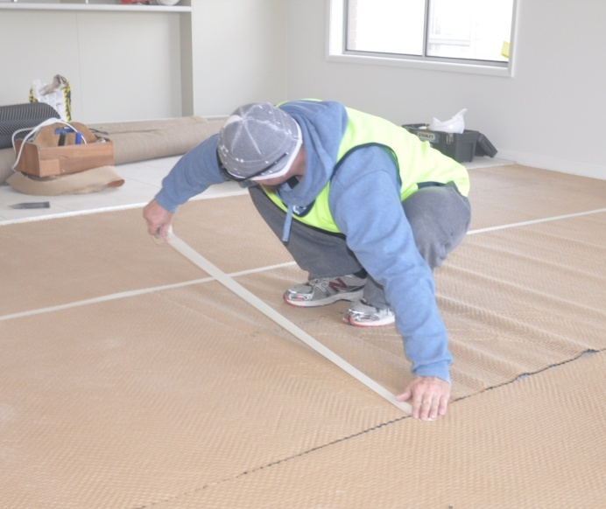
A resource is any material or energy source that goes into producing an item or achieving an outcome.
The most obvious resources used by floor layers are the physical products that go into the finished floor.
But there are many other resources consumed in the process of manufacturing these products, transporting them to the warehouse and packaging them for re-sale.
Taking a step further back, there are thousands of other resources involved in providing the infrastructure that makes the whole process possible, such as the production machinery required to make the products, the factories that house the machinery, and all the administrative services that support the operation.
In this section we’ll look at some examples of resources used by floor layers, and itemise the raw materials that go into their production.

Completing this section
The assignment for this section is designed to help you identify the types of resources you use and to measure their quantities. Have a look at Assignment 1 on page 11 to see what you’ll need to do to complete it.
There are also two lessons for this section:
- Identifying resources
- Measuring usage levels.
These lessons will provide you with background information and worked examples relevant to the assignment.

Identifying resources
Whether you’re involved in manufacturing, warehousing, sales, or on-site installation, you will use a wide range of resources at work.
Let’s take a typical example of a flooring installation, and look at the resources used in the process of laying a tongue and groove solid timber floor onto a concrete subfloor.

Timber strip flooring – materials and energy requirements
Below is a breakdown of the materials and energy requirements of a typical strip flooring installation.

Materials used in the installation:
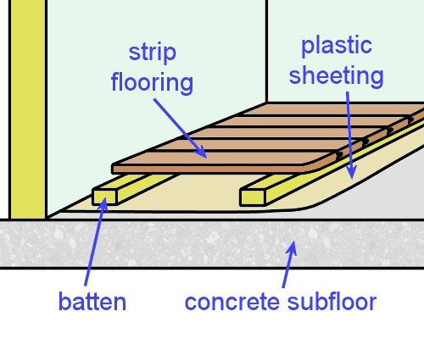
- strip flooring – as specified by the client
- timber battens – to fix to the concrete subfloor
- plastic sheeting and duct tape – to install the vapour barrier
- flooring nails and concrete nails – for fixing the strip flooring and battens
- construction adhesive – for gluing the flooring to the battens.

Other ‘consumable’ items used:
- saw blade – used to cut the timber
- cartridges for the power actuated nail gun – used to fire concrete nails through the battens and into the concrete subfloor.

‘Process’ energy used directly in the installation process:
- electricity – to power the saw and vacuum cleaner
- compressed air – to power the nail gun used to fix the flooring to the battens.

‘Non-process’ energy used to support the installation process:
- electricity to power lighting, appliances and other facilities
- fuel for the truck to take the products from the warehouse to the jobsite.
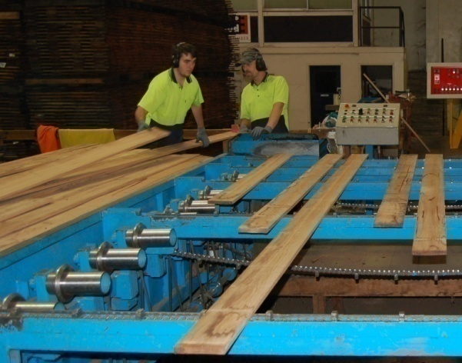
You can see from these lists that we are already getting a very big collection of materials and energy sources, and we haven’t even started on the resources involved in manufacturing the products.
On top of that, there are resources used in organising these activities, carrying out business transactions, and transporting the products from one stage to the next.
But staying with our on-site installation, let’s trace each of the items needed for this project back to the basic resources that came from the natural environment.

Natural resources
Items used in the installation | Natural resources used
Tongue and groove strip flooring | Solid wood from trees
Timber battens | Solid wood from trees
Plastic sheeting | Crude oil and chemical additives
Flooring nails and concrete nails | Iron ore and other mineral additives
Construction adhesive | Crude oil and chemical additives

Other consumables | Natural resources used
Saw blade | Iron ore and other mineral additives
Cartridges | Iron ore and other minerals for the casing, explosive chemicals for the propellant

‘Process’ energy | Natural resources used
Electricity | Mostly coal, plus water
Compressed air | As above, for the electricity to power the motor

‘Non-process’ energy | Natural resources used
Electricity | Mostly coal, plus water
Diesel fuel | Crude oil plus additives

Learning activity
Choose a floor covering product that you handle at work.
What is it made from? If there are several layers in the product, name each of the materials that make up the layers.
What naturally-occurring raw materials go into the make-up of these components?

Measuring usage levels
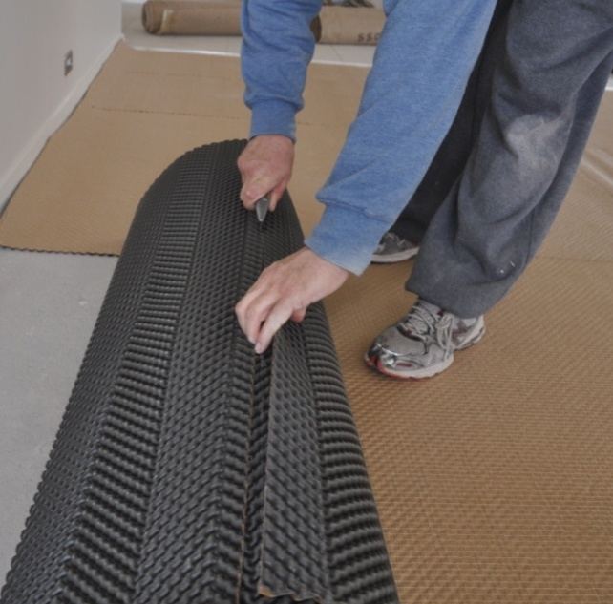
Working sustainably is all about making the most efficient use of natural resources, and producing the least amount of waste and pollution possible.
But before you can look for ways of improving efficiency, you need to have some idea of your current resource usage.
This gives you a benchmark to compare any improvements against. It also allows you to see how much you are saving, and which production methods work best and are the most economical.
It’s not always easy to measure all the resources you use, especially when some of them aren’t directly visible. For example, electricity consumption is hard to quantify unless you can put a power meter on every electrical item used in the job.
Usage levels are also hard to pin down if only a small proportion of a resource is used in an installation or manufacturing process – such as wear and tear on tools. However, there are still ways of measuring the usage of various resources so that you can make comparisons between the quantities being consumed over time.

Resource usage for a timber floor
Let’s see how we could quantify the materials and energy supplies that go into the installation of a timber floor. The tables below show the resources we identified in the last lesson, together with their units of measurement and typical quantities used.
Material or item | Unit of measurement | Quantity used
T&G strip flooring | Size (cross section) and length (lineal metres - l/m) | 83 x 19, 290 l/m
Timber battens | Size (cross section) and length (lineal metres - l/m) | 70 x 35, 52 l/m
Plastic sheeting | Width and length | 1200 mm wide, 22 l/m
Flooring nails | Size and quantity | 45 mm: 600
Concrete nails | Size and quantity | 65 mm: 25
Construction adhesive | Volume (L) | 1 litre

Other consumables | Unit of measure | Quantity used
Saw blade | Size and proportion of wear on teeth | 230 mm diameter, 1/10th of serviceable life
Cartridges | Charge and quantity | Medium charge, 25

Process energy | Unit of measure | Duration of use
Electricity | Operational time | Saw: 30 mins actual use
Compressed air | Operational time | Nail gun: 1.25 hours actual use
For the sake of the exercise, we won’t look at the details of the Non-process energy usage. However, at a management level, these forms of energy consumption are generally examined in close detail, because they can have a significant effect on the overall running costs of the company.
We will look at practical ways of reducing energy consumption in more detail in Section 3: Improving efficiency.

Learning activity
Identify a consumable resource or energy source you use at work where only a proportion is required for any given task.
Name the resource and the method you would use to measure its consumption.
Describe a specific task and estimate how much of the resource you would use up to complete that task.

Assignment 1
Go to the Workbook for this unit to write your answers to the questions shown below. If you prefer to answer the questions electronically, go to the website version and download the Word document template for this assignment.
___________________________________________________________________________
Choose a particular type of installation you carry out, or a task you regularly undertake at work, and then answer the questions below. You may use the same examples from the learning activities as a starting point for your answers.
Identifying resource usage
1. Describe the type of installation or the task.
2. (a) What materials and other items are used to complete the installation or task?
(b) Which natural resources do these materials and items come from?
3. (a) What other consumable items are used in the project?
(b) Which natural resources do these consumables come from?
4. (a) What are the ‘process’ energy requirements for the project?
(b) Which natural resources are needed to provide these energy requirements?
5. (a) What are the ‘non-process’ energy requirements for the project?
(b) Which natural resources are needed to provide these energy requirements?
Measuring resource usage
6. Write down the quantities of the materials, items and other consumables that go directly into the finished project. Also specify the unit of measurement you have used to quantify the amounts.

Section 2

Environmental issues at work

Overview
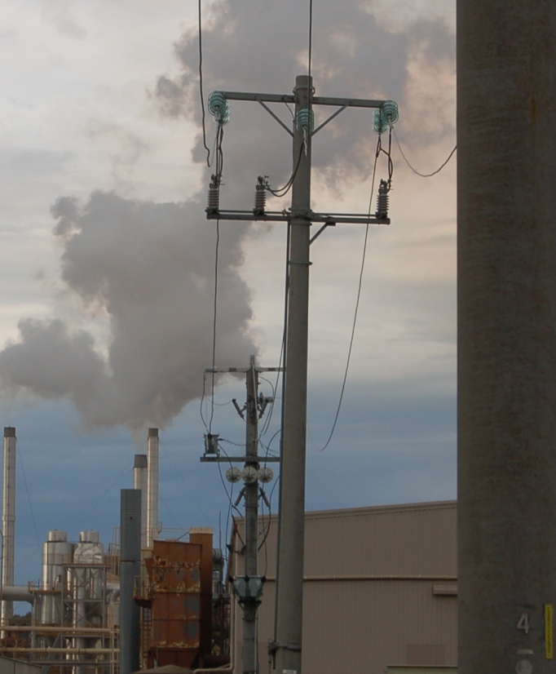
Over the last few years, environmental controls and regulations have become increasingly strict.
This reflects the growing understanding that we need to be more careful about the resources we use and the wastes and pollution we produce.
Communities have realised that if we don’t take more care, the way we live and go about our business can have an incredibly damaging effect on the natural world around us.
In this section, we’ll look at the main environmental issues that concern businesses in the furnishing industry.
We’ll also discuss the effect that laws and regulations have on the way a business operates, and the obligations they impose on employees as they carry out their day-to-day work.

Completing this section
The assignment for this section will ask you to examine a range of environmental protection issues at your own workplace.
Have a look at Assignment 2 on page 23 to see what you’ll need to do to complete it.
There are five lessons for this section:
- Air quality
- Stormwater
- Trade wastewater
- Hazardous substances
- Laws and procedures.
These lessons will provide you with background information relevant to the assignment.

Air quality
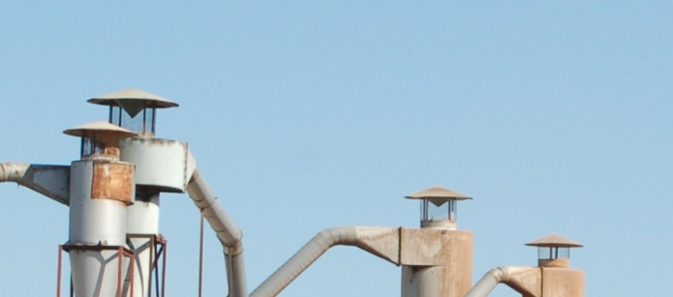
Clean air is something that most people take for granted.
But on building sites and in manufacturing workplaces there are many contaminants that can pollute the air if they’re not kept under tight control.

Volatile organic compounds
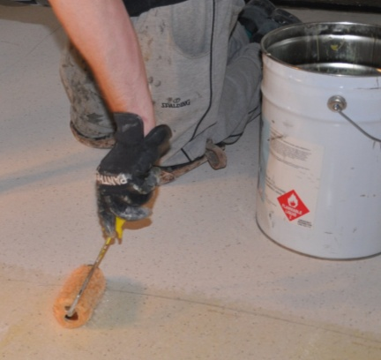
Volatile organic compounds (VOCs) are chemicals that can evaporate into the air and cause serious environmental problems and chronic health conditions. They include formaldehyde, adhesives, paints, protective coatings and other solvents.
The best way to limit the amount of evaporation when you’re not using these substances is to keep the containers well sealed.

Dust
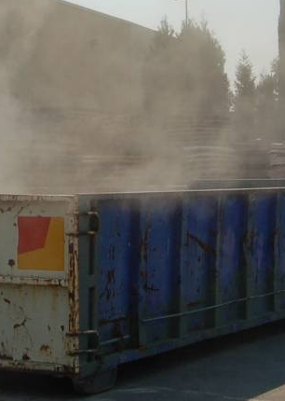
One of the most obvious airborne problems is dust. Some types of dust are toxic, particularly if they contain formaldehyde glues or other chemicals.
Even common forms of dust can produce fallouts in the neighbourhood. And if people are exposed to them for a long time, they can cause health problems.
There are two main ways of managing dust that is generated in the workplace:
- good housekeeping, and
- collecting the dust as close to its production source as possible.
A dust extraction system is the easiest way to control dust at its source. The equipment can either be connected to a centralised unit, or individual machines can have their own systems. You can also control dust build-up by sweeping or vacuuming the area.
Note that some dusts require the use of personal protective equipment (PPE) while you’re exposed to it. If you’re not sure whether you need to wear PPE, ask your supervisor before you begin to clean it up.

Burning
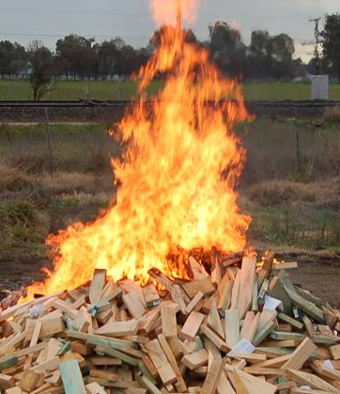
Burning off waste products or rubbish can cause serious air pollution, especially when the waste contains plastics or other chemical compounds. Even ordinary paper and other wood-based products can be responsible for problem emissions and smoke haze.
In general, open air burning is not allowed by local councils, particularly in metropolitan areas, unless you’ve got a permit. Apart from the emissions it creates, open air burning can be a serious fire hazard in the hotter months of the year.

Learning activity
What types of activities do you undertake at work that release air pollutants, or have the potential to reduce the air quality?
If you don’t directly engage in these sorts of activities, what products do you handle that could affect the air quality if they were not stored or disposed of in an appropriate way?
See if you can name one form of dust and at least one other example of an air pollutant.

Stormwater
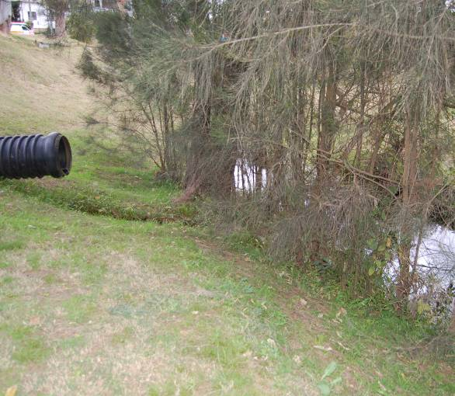
Every time it rains at your workplace, the water washes over the outside areas, and either soaks into the ground or disappears down the stormwater drains.
These drains generally come out at the local creek or canal, and eventually discharge into a river, harbour or beach.
Unlike sewerage, stormwater isn’t treated to remove any pollutants that are in it.
So if it’s contaminated with litter, wastes, grease, oil or other chemicals, these will find their way into the natural environment, where they can have a serious effect on the fish, plants and other life forms living in that ecosystem.
That’s why it’s an offence to allow stormwater to become polluted. This includes placing substances in a position where they can fall or be blown into a local waterway, gutter or drain. It also includes allowing silt to wash into the stormwater and send it murky, or ‘turbid’.

Simple things you can do
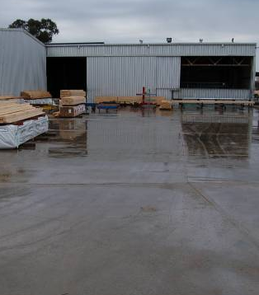
There are many simple things you can do on a day-to-day basis to stop rainwater from becoming polluted as it runs off into the stormwater drains. These include:
- making sure that contaminates aren’t allowed to accumulate in areas where they could be washed away by rain, especially near drains
- keeping driveways and yard areas free of litter
- providing containers for cigarette butts
- keeping drains clear, to allow the free flow of water when it rains.

Learning activity
Name a substance or material at your workplace that could end up going into the stormwater system and polluting the waterways if there weren’t measures in place to stop it from happening.

Trade wastewater
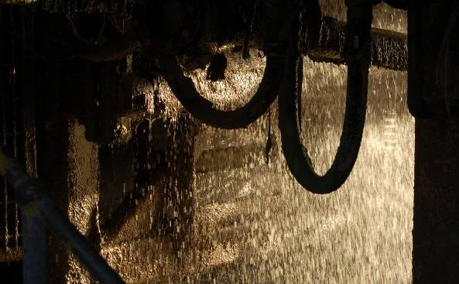
Trade wastewater is any wastewater produced by a commercial or industrial activity. It doesn’t include sewerage from toilets or sinks, but does include the run-off from industrial sprays and cooling systems.
Wastewater isn’t always toxic, but even non-toxic wastewater can be harmful if it’s put straight into the sewer without the problem substances being removed first.
Before you let wastewater go into the sewerage system, you need to remove the contaminants, and your company needs to get a wastewater permit from the local water authority. This permit will specify the treatment process required and any other standards that may apply.
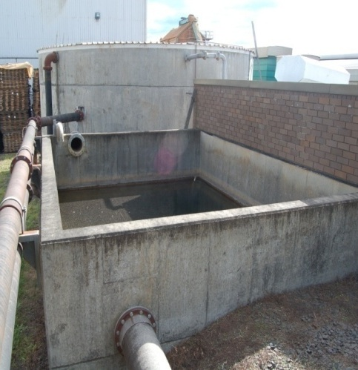
But not all businesses need to put their wastewater into the sewerage system. Some companies recycle the wastewater on-site, and treat it so it can be used in other production processes or for watering the garden.
Other companies collect the wastewater in drums, and have it taken to a waste disposal station. But remember that if you’re sending it to a waste facility, the transportation must always be done by a licensed contractor.

Learning activity
Does your company produce trade wastewater? If it does, what types of contaminants are held in the water? How are the contaminants disposed of?
If your company doesn’t produce trade wastewater, see if you can think of a product you use that would result in trade wastewater being generated during its manufacture. What is the product? What types of contaminants would be held in the wastewater?

Hazardous substances
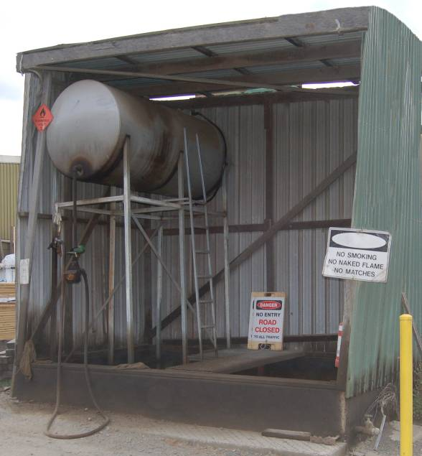
Hazardous substances are any substances that might be harmful to people’s health or cause damage to the environment.
They range from common household products like solvents and pesticides through to thousands of other liquids, gases and materials used in workplaces.
Some hazardous substances, such as gas and diesel fuel, are classified as dangerous goods. Their storage, transportation and use are controlled by law, because of their potential to cause fires or explosions.
Every hazardous substance is required to have a material safety data sheet (MSDS), which is published by the manufacturer of the substance. The MSDS is designed to give you important information on how to use the product safely, how to store it and transport it, and what to do if the substance spills.
Dealing with spills
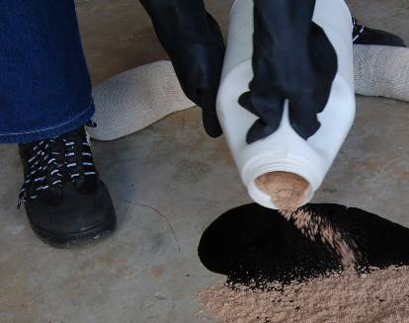
Spills can be a real problem when they involve a hazardous substance. They should always be cleaned up straight away, no matter how small they are.
Quite apart from any safety risks involved, you don’t want the spill to escape into the stormwater system or soak into the ground and cause contamination.
If you have a serious spill at your workplace, or if you’re worried about safety, call the fire brigade on 000.
Note that if a spill occurs that might harm the environment, you must tell the Environment Protection Authority (EPA) or local council as soon as you become aware of it.

General guidelines on handling and storage
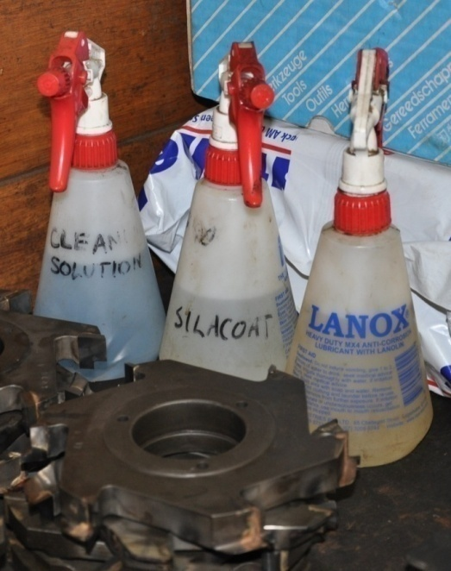
Here’s some general guidelines to follow when you’re handling or storing hazardous substances.
- Store chemicals in their own area, away from stormwater drains and out of the weather.
- Never use plain drink bottles or other unmarked containers to store chemicals.
- Clearly label all containers with the name of the product it contains if it is no longer in its original packaging.
- Keep ‘incompatible’ chemicals well away from each other, that is, chemicals that are likely to react with each other.
- Dispose of hazardous waste properly, using a licensed contractor to take it to a licensed depot.
- Make sure that all vehicle activity is carried out well clear of the chemical storage area.

Learning activity
Where are the MSDSs kept for the hazardous products you use at work?
Get a copy of an MSDS for a particular product you commonly use. You will need it to answer the MSDS questions in the assignment for this section.

Laws and procedures
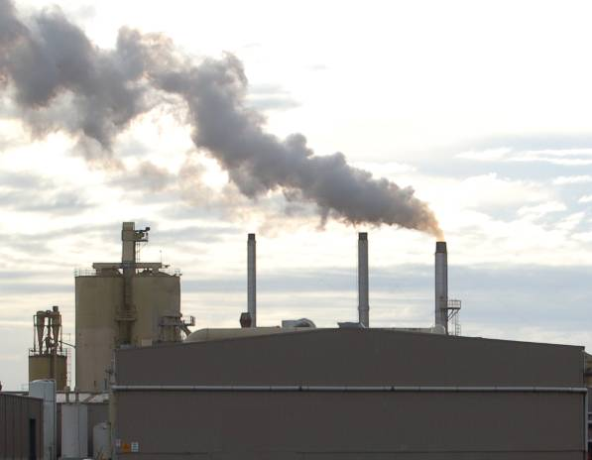
In each state the Environment Protection Authority (EPA), or its equivalent body, oversees the laws concerning environmental care.
One of their main functions is to regulate the activities of large industries and issue notices if companies do the wrong thing. If the offence is serious enough, they will prosecute the company.
Local councils also play a role in environmental protection, and regulate smaller businesses and industries through planning controls, notices and prosecutions.

Obligations on employees
Generally speaking, the company you work for will have already built the relevant environmental laws and regulations into the policies and procedures you follow every day at work.
But it’s worth keeping in mind that some laws go beyond the obligations placed on the company, and extend directly to all employees and contractors working at the site.
For example, the law states that if pollution occurs when you’re doing something and it threatens or harms the environment, you must tell the EPA or the local council as soon as you can. This allows the authorities to take steps to minimise the impact of the problem before it gets out of hand.

Learning activity
Give one example of an environmental policy or procedure at your workplace that directly affects the work you do.
Explain how it affects the way you carry out a particular task.

Assignment 2
Go to the Workbook for this unit to write your answers to the questions shown below. If you prefer to answer the questions electronically, go to the website version and download the Word document template for this assignment.
___________________________________________________________________________
Some of the questions below follow on from the learning activities in this section. You may start with the same examples you raised in the learning activities and build on them for these answers.
Controlling air quality
1. (a) Name a substance or emission produced at your workplace that would reduce the air quality if it was not properly controlled.
(b) Describe the control measures your company takes to manage the problem.
Protecting stormwater
2. (a) Name a substance or material at your workplace that could end up polluting the stormwater system if there weren’t measures in place to stop it from happening.
(b) Describe the control measures your company takes.
Reading an MSDS
3. Choose a Material Safety Data Sheet (MSDS) that relates to a product you use at work. Answer the following questions.
- What is the trade name or technical name of the product?
- What is the product used for? Provide a brief description of the product.
- Is there a fire risk with the product? If so, what equipment is required to put out a fire?
- What should you do in the event of a spill? Describe the clean-up process.
- How should you dispose of the product?
Following procedures
4. (a) If there was an environmental incident or problem at your workplace, who would you report it to on-site?
(b) When does an incident need to be reported to the Environment Protection Authority?

Section 3

Improving efficiency

Overview
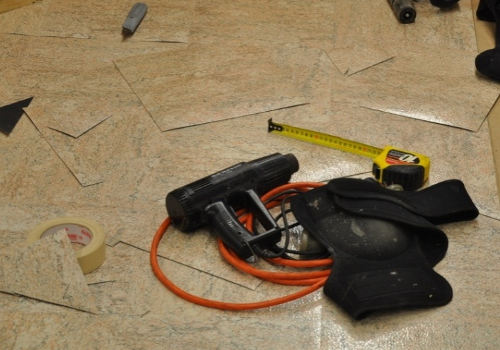
There are many things you can do to help the company use resources more efficiently.
In this section, we’ll look at some simple measures that can be carried out in the workplace at any time.
You’ll probably agree that all of these actions are commonsense, and you may already be doing some of them.
But it helps to remember that each positive action makes its own contribution to a more environmentally sustainable workplace, and in the end, a healthier natural world.
At an economic level, most of these ideas will also save your company money. You’ll be using less materials, consuming less power and disposing of less waste. So you can be pretty confident that if you’re not already making use of these ideas, your boss will support any new measures that have the effect of improving the company’s efficiency and profitability.

Completing this section
The assignment for this section asks you to think about the sustainability measures in place at your own your own worksite.
Have a look at Assignment 3 on page 33 to see what you’ll need to do to complete it.
There are three lessons for this section:
- Using less power
- Using less water
- Managing waste.
These lessons will provide you with background information relevant to the assignment.

Using less power
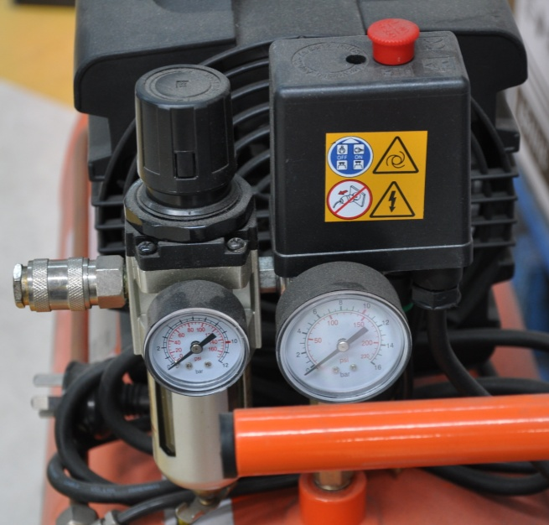
Reducing the amount of electricity you use at work will not only save your company money, it will also make a difference to the greenhouse gas emissions produced by power generators.

Lighting
The simplest ways to reduce artificial lighting costs are to:
- use natural light as much as possible
- turn off the lights that aren’t needed.

Equipment
With equipment, you’ll save power by:
- turning off the machine when you’re not using it
- cleaning and maintaining equipment regularly
- replacing inefficient parts or machines
- checking air hoses and compressors for leaks.

Learning activity
Think about the ‘non-process’ power usage in your workplace – that is, the electricity used in activities not directly related to production.
Areas could include amenities buildings, lunchrooms, kitchens, store rooms, and so on.
Are there any actions that could be taken to conserve power usage? Describe what they are and who would be involved.

Using less water
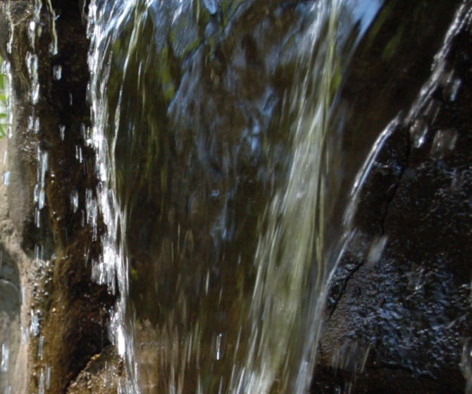
There was a time when people didn’t give much thought to how much water they used at home and work, because it seemed that the supply was endless and it cost almost nothing. But those days have gone.
Many manufacturing businesses now use rain water, bore water or recycled water to supplement their supply. They have also installed more efficient appliances and equipment where possible.
However, there are various things that anyone can do on a day-to-day basis to reduce their consumption of this scarce natural resource.
Firstly, of course, you need to comply with any local government water restrictions. This may include not hosing hard surfaces, and not using sprinklers. Secondly, use mulch on garden areas, to reduce the amount of outdoor watering you need to do. And thirdly, fix leaking taps or fittings, so you don’t lose any water unnecessarily.
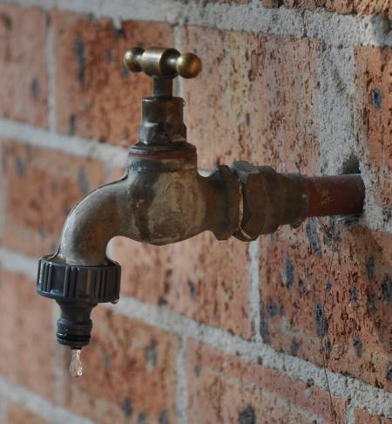
Just to give you an idea of the savings these simple measures can make, here are some facts and figures on common water usages and wastages.
- A dripping tap loses between 30 and 200 litres a day.
- A leaking fitting, or a pipe with a 1.5 mm hole in it, can lose 100 litres of water a day.
- A leaking toilet cistern can lose from 35 litres a day, for water that is just visible in the pan, up to 260 litres, for water that makes a constant hissing sound.

Learning activity
Take a walk around your worksite and look for any areas where water is leaking or being used unnecessarily. The issues you find could include dripping taps, leaking connections, inefficient sprinkler systems, or even work practices that use excessive water. Describe the problem and the best way to fix it. Who would you report this problem to?

Managing waste
It goes without saying that the easiest way to deal with the problem of waste is not to create it in the first place.
But that’s not always possible, of course, so the next best way to minimise waste is to try to re-use the materials wherever you can.
If you can’t do that, you then have to consider whether the discarded items could be broken down to their raw materials again and made into new products.
This hierarchy of options is referred to the 3 Rs – Reduce, Reuse, Recycle.
Notice that disposal doesn’t even rate a mention in the 3 Rs, because it is the last resort, and should only be used if you’ve already exhausted the other possibilities.
Here are some practical examples.

Reduce
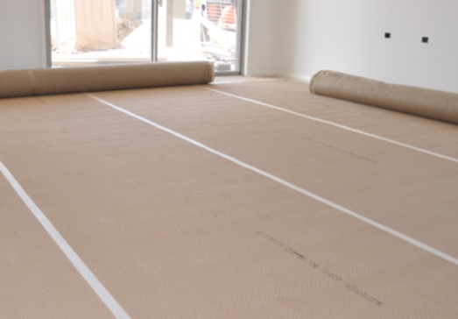
Try to use materials as efficiently as you can, and minimise the amount of reject material you produce.
If you need to cut certain items to specific sizes, work out which stock sizes will give you the best recovery, and therefore the least amount of off-cuts.

Reuse
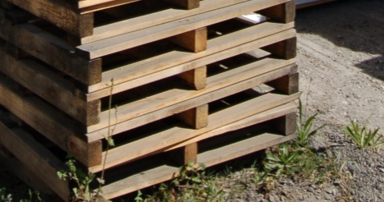
See if your suppliers can deliver their products in returnable packaging, such as pallets and drums.
Then they can pick them up when they drop off your next order. The same thing applies to plastic containers.

Recycle
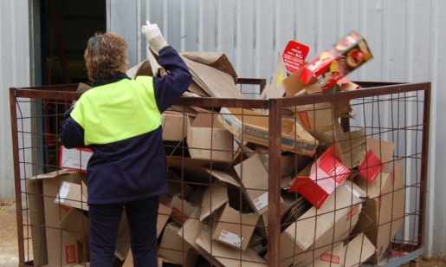
Many products are now recyclable, and some companies offer to pick them up for free or even pay you by the tonne when they collect them.
Common recyclable materials include glass, aluminium, steel, plastic, paper and cardboard, and toner cartridges.
In recent years there have been efforts made to collect and recycle old vinyl flooring products, rather than sending the waste material to landfill. These efforts have been supported by industry schemes such as the Vinyl Council’s Product Stewardship Program and the Green Star Best Environmental Practice Guidelines for PVC.
Polyflor was the first Australian commercial flooring manufacturer to achieve a certification under the Green Star system for its 100% recyclable flooring products.
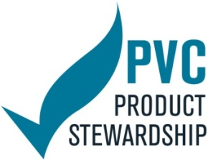
Some manufacturers are also starting to use significant amounts of recycled PVC in their new flooring lines. Armstrong flooring, for example, recycles old vinyl tiles and PVC bottles, and has two products – ‘Eco Accolade’ and ‘Eco Terrazz’ – that contain over 50% recycled material.

Disposal
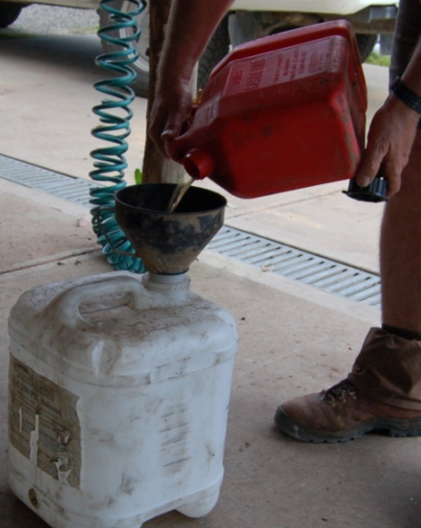
If you need to store waste while it’s waiting to be picked up and disposed of, make sure it is kept secure so that it doesn’t blow away or escape into the storm water system.
Remember, too, that you mustn’t bury waste on-site – this constitutes a landfill activity and is illegal unless your company has an EPA waste licence.
Never put liquid waste into the waste bin. Materials in the waste bin generally go to landfill, so it should only ever be used for dry, solid waste.
Always drain and clean anything containing leftover fluid before you put it in the bin. Depending on the type of liquid it is, you can then either recycle or treat it, or put it aside for removal by a waste disposal contractor.

Learning activity
To see an interesting poster on the decomposition rates of different types of garbage, go to the web page shown below. The poster is called ‘How long until it’s gone’.
http://www.activeseakayaking.ca/how-long-until-its-gone/
For more details about the use of recycled PVC in vinyl flooring products, go to the following article by David Wheeldon, published on the Building Products News website at:
http://www.bpn.com.au/features/bpn-reports/vinyl-flooring-product-review
Under the subheading ‘Product news’ (halfway through the above article), there are brief summaries of the latest products released by the main manufacturers.
Do you use any of these products? What sorts of projects have you used them in?

Assignment 3
Go to the Workbook for this unit to write your answers to the questions shown below. If you prefer to answer the questions electronically, go to the website version and download the Word document template for this assignment.
___________________________________________________________________________
Managing waste
1. What are the ‘3 Rs’ of waste management?
2. Name an item or material that you apply this principle to at work, and describe what you do with it. If you don’t already apply this practice, describe what you could do in the future
Suggesting improvements
3. Choose one type of product you use regularly at work. Identify a brand name that is marketed as ‘environmentally friendly’ by the manufacturer. You may already be using this brand name product, or you may simply have heard that it is available as an alternative to the product you’re currently using.
Answer the following questions:
- What is the brand name and who is the manufacturer?
- What type of product is it?
- What features make the product more ‘environmentally friendly’ than alternative (or more traditional) products?
4. Who is responsible for environmental care in your workplace?
5. If you came up with a new idea that made a work activity more environmentally friendly, how would you go about putting it to the company?

